数字电子技术

考核：30%平时+70%期末考试

【如有错误 [请联系3415124757@qq.com](mailto:请联系3415124757@qq.com)修改】

# 1.1Digital and Analog Quantities (数字量与模拟量)

advantages of digital data as compared to analog data：

1.can be stored, processed, and transmitted（传输）more efficiently and reliably than analog data

2.simpler to implement（实现）and there is a greater immunity（免疫）to noisy environments

3.can be compressed

disadvantages: can only assign discrete（离散的）values to each point（not infinite）

Analog: time/value continuous

Digital: time/value discrete

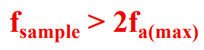

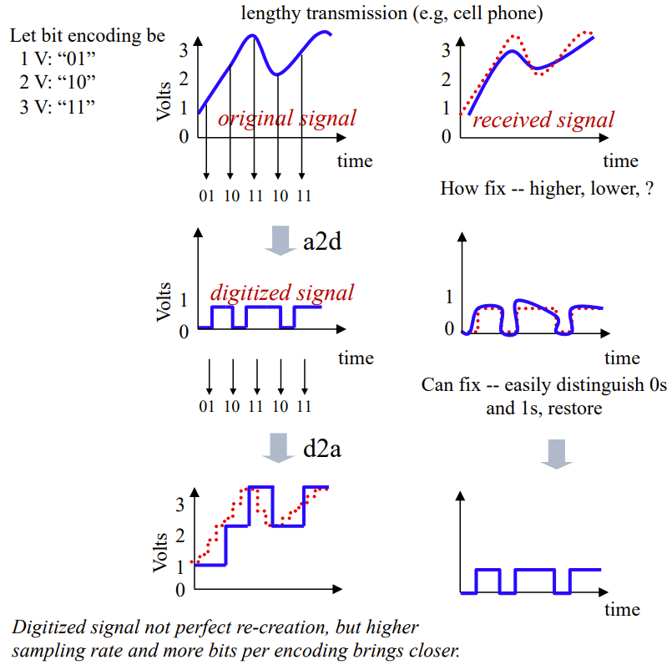A2D:

# 1.2 Binary Digits, Logic Levels, and Digital Waveforms (二进制数、逻辑电平与数字波形)

A binary digit is called a bit.In digital systems, combinations of the two states, called codes.

Each bit in a sequence occupies a defined time interval called a bit time, or bit interval.

The voltages used to represent a 1 and a 0 are called logic levels.

Digital waveforms consist of a series of pulses, with voltage levels changing back and forth between the HIGH and LOW.

Positive–going pulse/ Negative–going pulse

Actual pulses

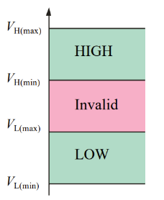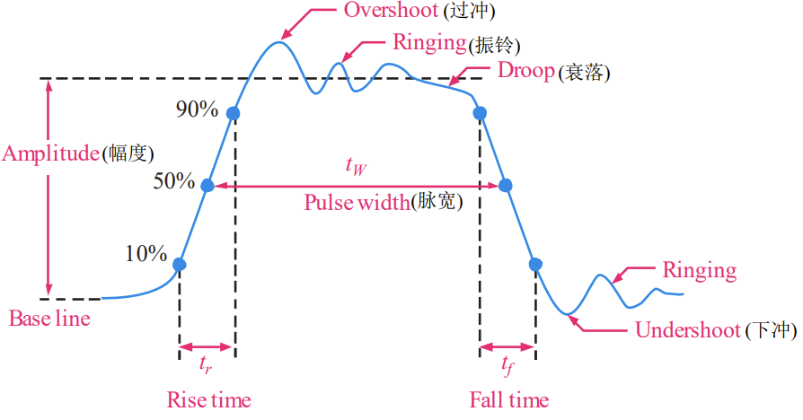

Periodic (square wave) : frequency(f)（单位是Hz） period(T)/ Nonperiodic

kHz（即1000Hz）、MHz（即1000kHz）、GHz（即1000MHz）、THz（即1000GHz）

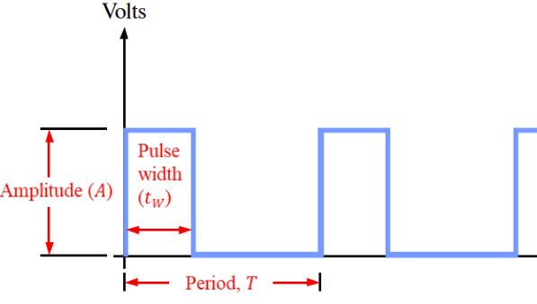

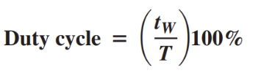

Timing Diagrams (时序图): show the relationship between two or more digital waveforms

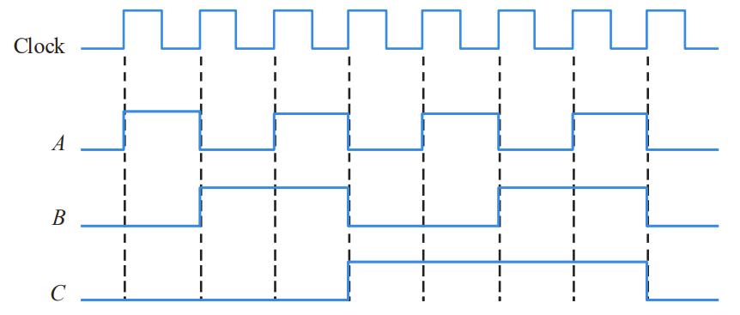

Clock:不承载信息

Data Transfer (数据传输)：

Serial data transfer: one bit at a time along a single conductor.

Parallel data transfer: sent out on separate lines at the same time.

# 1.3 Fixed-Function Logic Devices

Pin Numbering:

Pin1 is indicated by an identifier that can be either a small dot, a notch, or a beveled edge. 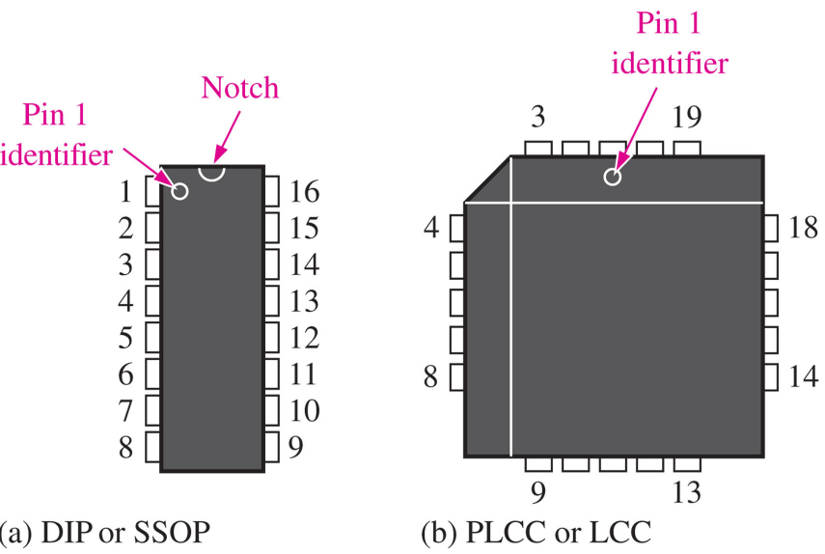

# 2.1 Decimal Numbers (十进制数)

位权展开式

括号加下标表示进制：D:10; B:2; O:8; H:16;

# 2.2 Binary Numbers (二进制数)

二进制与八进制/十六进制的转换：从右往左三/四为一划分

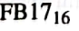Eg:

其中要注意是1和7，而不是17（因为是16进制，不可能出现比15大的）

16进制中A~F分别表示10~15

# 2.3 Decimal-to-Binary Conversion (十进制与二进制转换)

1.拼凑（从最高位开始）

2.整数部分：除2取余法 小数部分：乘二取整法（最先得到的数放在靠近小数点的位置）

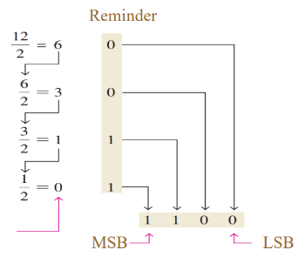The first and last reminders correspond to the LSB and MSB in the binary number.

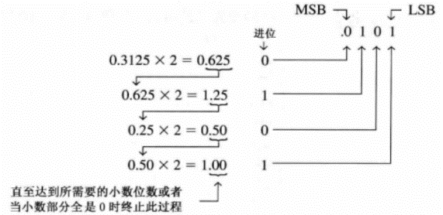取几位小数：

(for …significant digits)

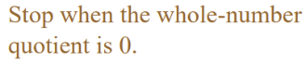

# 2.4 Binary Arithmetic (二进制算术运算)

加Add the binary numbers … and … and show the equivalent decimal addition.

减Subtract the binary number … from …

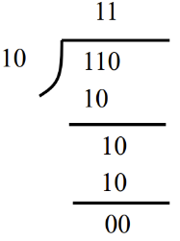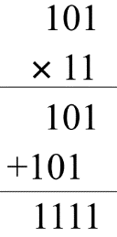乘除

# 2.5 Signed Numbers (有符号数)

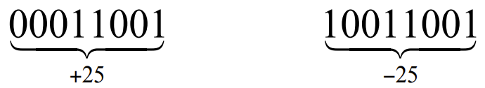Sign-Magnitude(大小) System：最左侧符号位：1为负 0为正

1’s Complement(反码)：0变1，1变0

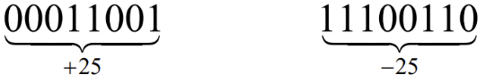

The weight of the sign bit is given a negative value.

Adding 1 to the result.（负数）（正数不用加1）

2’s Complement (补码):

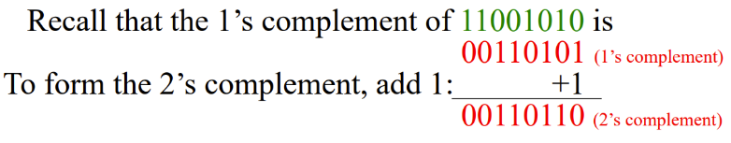

The weight of the sign bit is given a negative value.

No adding 1 to the result.

An alternative method of finding the 2’s complement:

Step1: Start at the right with the LSB and write the bits as they are up to and including the first 1.

Step2: Take the 1’s complements of the remaining bits.

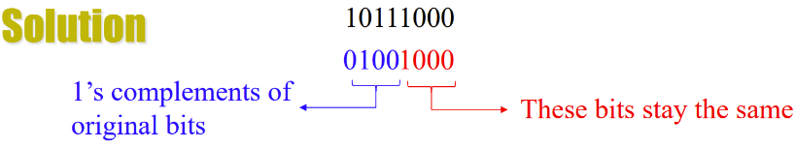

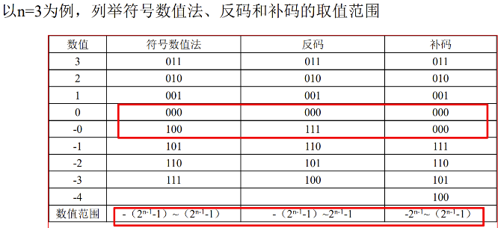

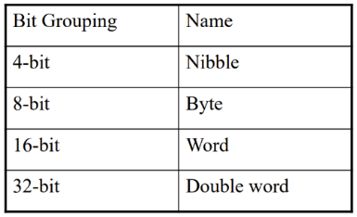

用于判断一个数字用多少bits存储

# 2.6 Arithmetic Operations with Signed Numbers (有符号数的算术运算)

Addition: Add the two signed numbers. Discard any final carries. The result is in signed form.

The overflow will be indicated by an incorrect sign bit.

（即overflow can occur if both numbers have the same sign）

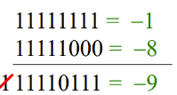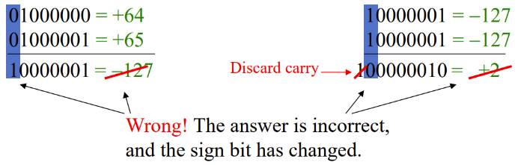

Subtraction:

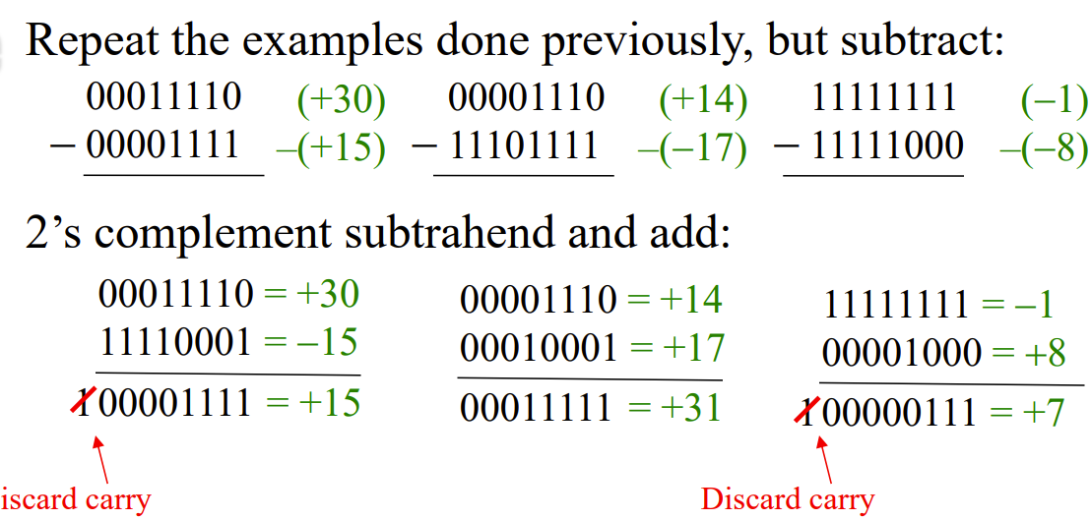

Multiplication:



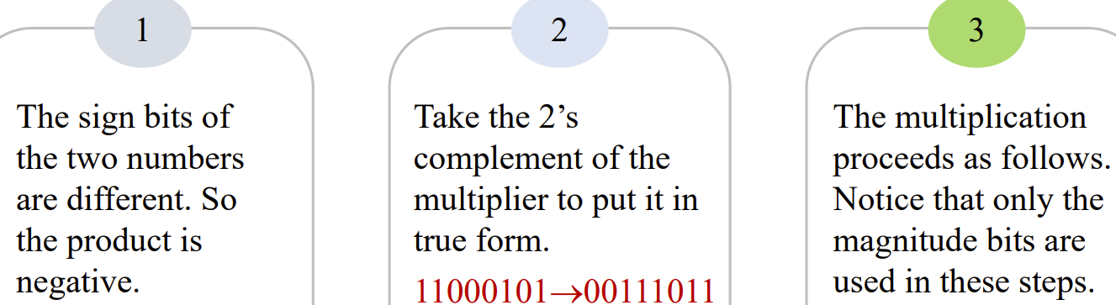

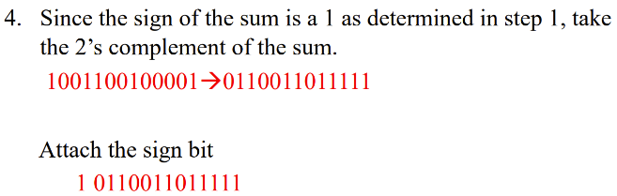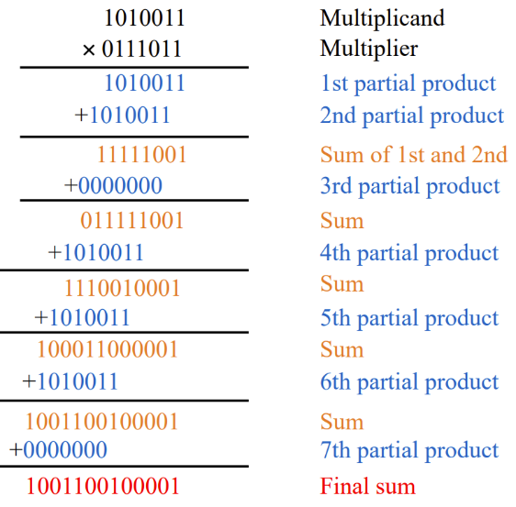

Division: The two numbers in a division are the divisor（除数）and the dividend（被除数）. The results are the quotient(商) and the remainder(余数).

Divide a by b: (a除以b)

# 2.10 Binary Coded Decimal (BCD码)

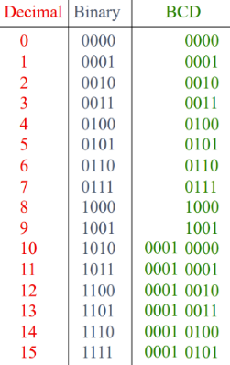1010, 1011, 1100, 1101, 1110, and 1111 are invalid codes.

For an 8-bit BCD number, the column weights are: 80 40 20 10 8 4 2 1.

BCD Addition:

If a 4-bit sum is greater than 9, or if a carry out of the 4-bit group is generated, it is an invalid result. Add 6 (0110) to the 4-bit sum in order to skip the six invalid codes and returned the code to 8421. If a carry occurs when 6 is added, simply add the carry to the next 4-bit group.

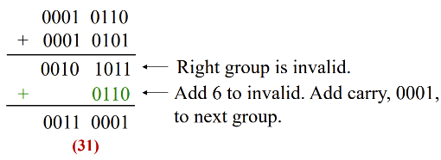

加了0110后又有进位，此时不用再加0110

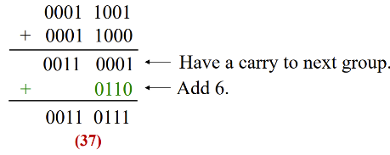

# 2.11 Digital Codes

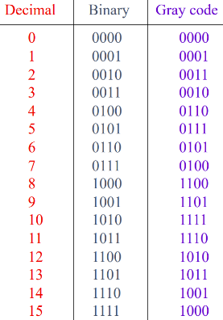Gray Code: has a single bit change between one code word and the next in a sequence.（翻折对称）

Binary-to-Gray Code Conversion：

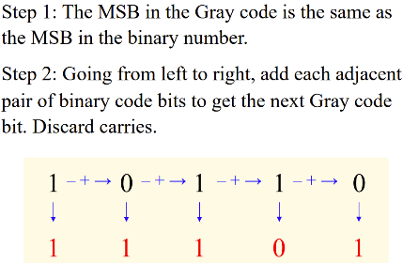

Gary-to-Binary Code Conversion：

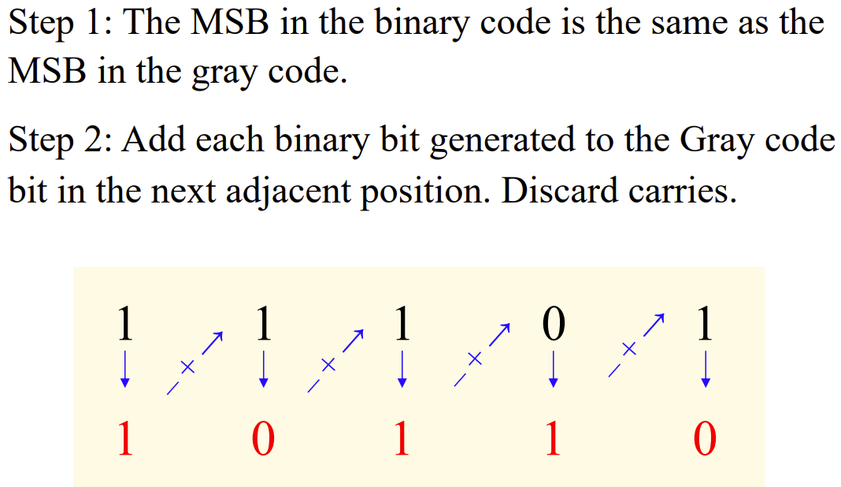

# 2.12 Error Detection Codes

Parity Method (奇偶校验)：1的个数（even（偶）or odd（奇）).

Question: How many XOR gates will be used in a binary odd parity checker with four inputs?

Answer: three.

# 3. Logic Gates＋5. Basic Combinational Logic Circuits

|  |  |  |  |
| --- | --- | --- | --- |
|  | Truth table | symbol | Boolean expression |
| inverter |  |  |  |
| And |  |  | X = AB |
| or |  |  | X=A+B |
| NAND 与非 |  |  |  |
| NOR |  |  |  |
| XOR  异或  Exclusive-or |  |  |  |
| XNOR  同或 |  |  |  |

AND-OR 与或

AND-OR-Invert 与或非

The dual of：……的对偶

The AND operation is the dual of the OR operation.

Universal Gates：

1. NAND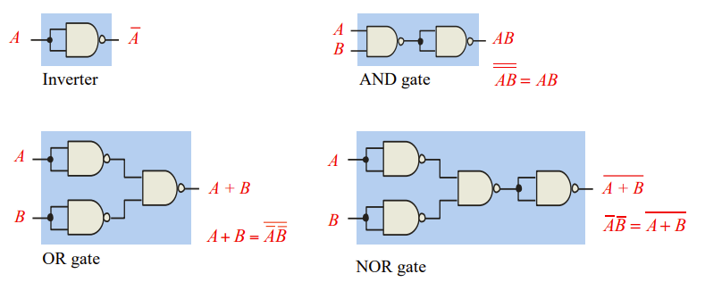

NAND=negative-OR(与非=非或)

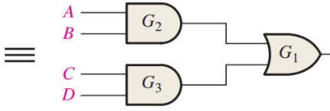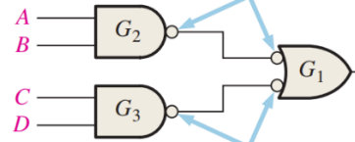例如：邻接的两级与非门分别用与非门和非或门表示，读图更方便。

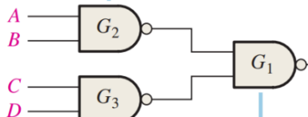

1. NOR

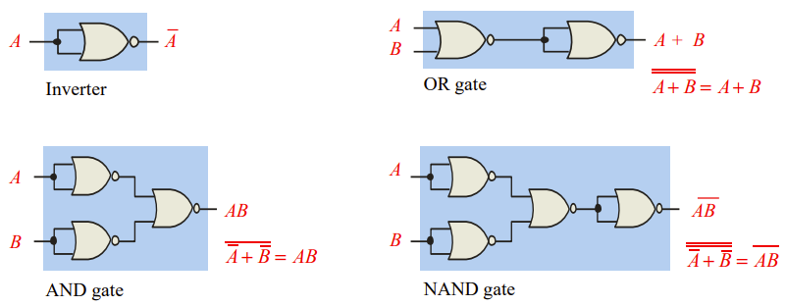

NOR=negative-AND（或非=非与）

同理，邻接的两级或非门分别用或非门和非与门表示，读图更方便。

propagation delay:

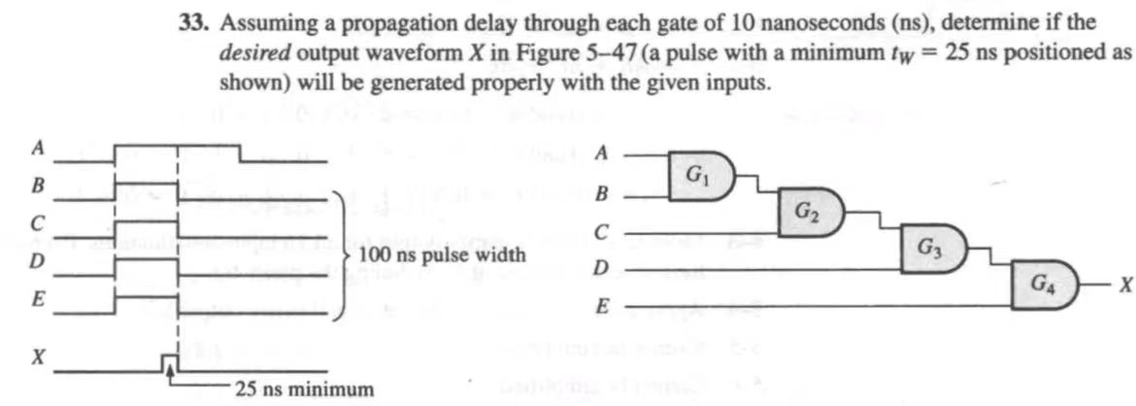

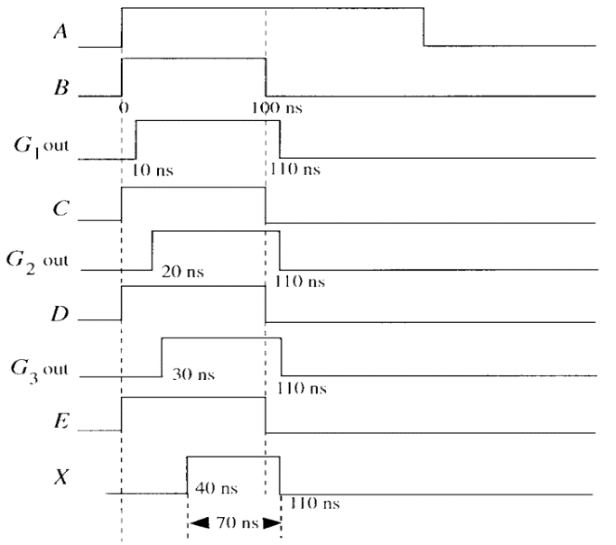

# 4.1Boolean Operations and Expression（布尔运算及表达式）

Boolean Addition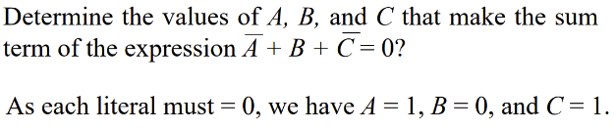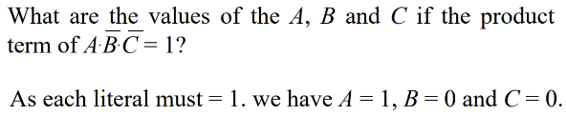/Multiplication：

# 4.2Laws and Rules of Boolean Algebra (布尔代数运算法则)

**commutative laws：（交换律）**

addition：A + B = B + A；

multiplication：AB=BA;

**associative laws：（结合律）**

addition：A + (B +C) = (A + B) + C;

multiplication：A(BC) = (AB)C;

**distributive law：（分配律）**

AB + AC = A(B+C);

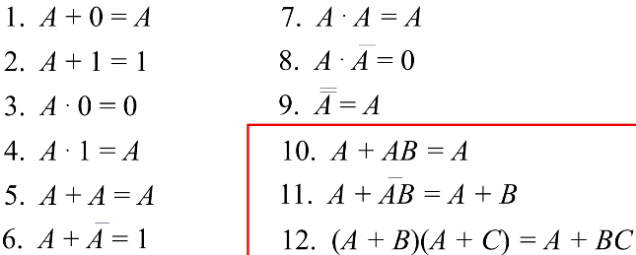Rules of Boolean Algebra:

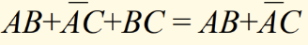Consensus Theorem (多余项乘积定理): 当逻辑表达式中某个变量如A，分别以原变量和反变量的形式出现在两项中，这两乘积项的其余部分组成的第三项，如BC，必为多余项.

Duality Theorem (对偶定理): replacing all + operators with • , and • operators with +, all 1s with 0s, and all 0s with 1s

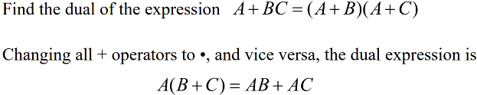

DeMorgan’s Theorem:

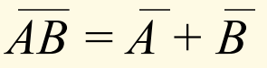1st:

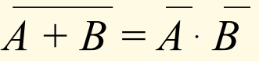

2nd:

# 4.5 Simplification Using Boolean Algebra:

Reduce a particular expression in its simplest form to use the fewest gates.

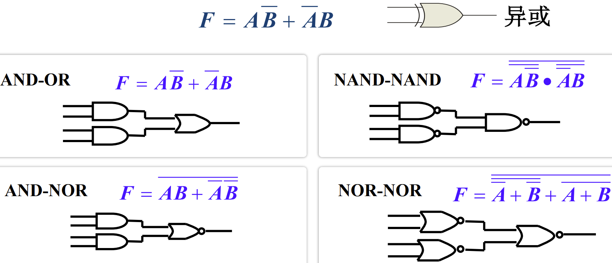

using repeated terms:

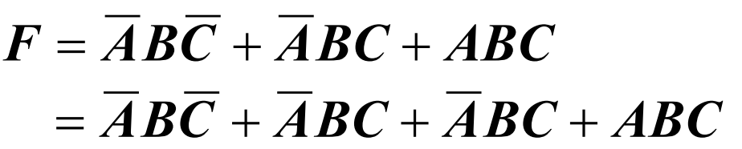

例题：

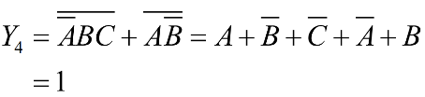

(要注意这里是逻辑门，无论C取何值，都是1)

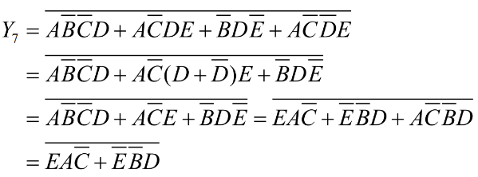

# 4.6 Standard Forms of Boolean Expression:

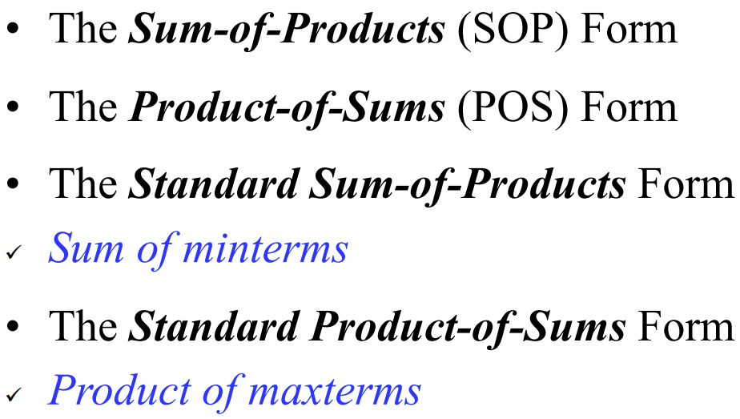

Standard SOP Form：every variable in the domain must appear in each term.



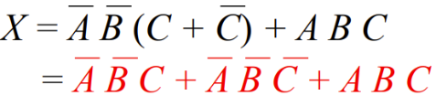

Standard POS Form：every variable in the domain must appear in each sum term of the expression.



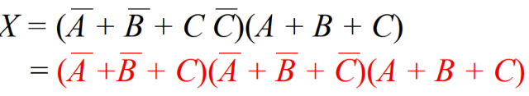

Tip：(A + B) (A + C) = A + BC

# 4.7 Boolean Expression and Truth Table

Conversion of SOP Form to Truth Table：

Place a 1 in the output column for each binary value that make the standard SOP expression a 1 and place 0 for all the remaining binary values.

Conversion of POS Form to Truth Table：

Place a 0 in the output column for each binary value that make the standard POS expression a 0 and place 1 for all the remaining binary values.

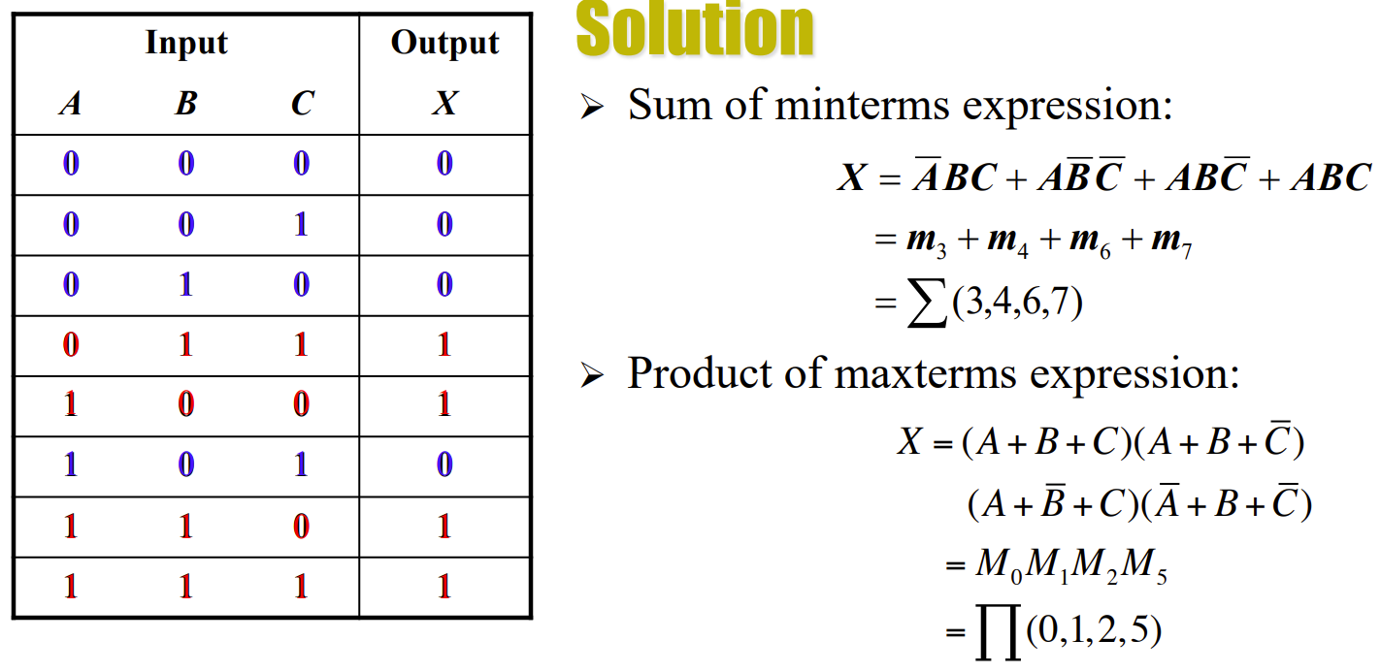

Conversion between Truth Table and Logic Function: 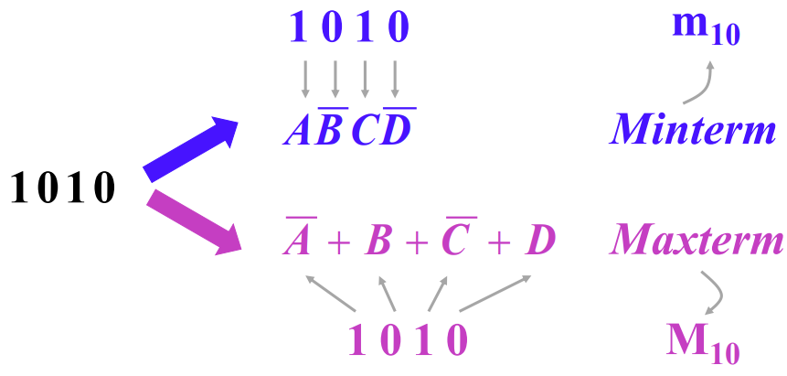

例题：

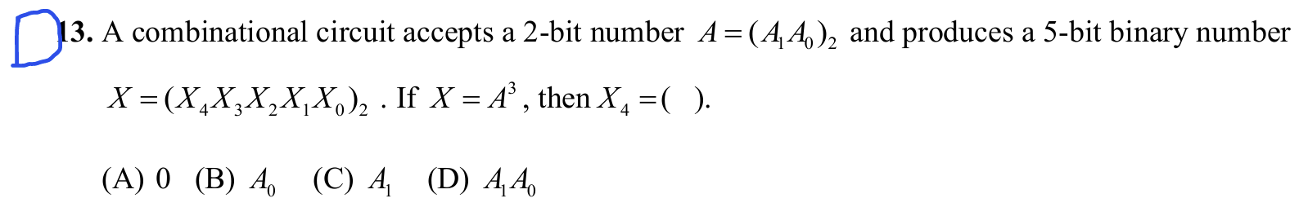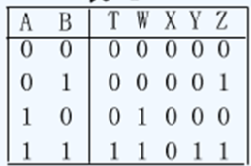列出功能表，X4=1当且仅当AB = 1

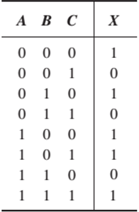

NOR-NOR 此时需要将X写成POS形式 方便表示

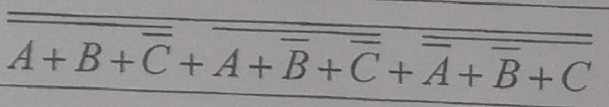

# 4.8 The Karnaugh Graph

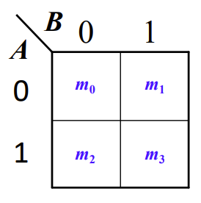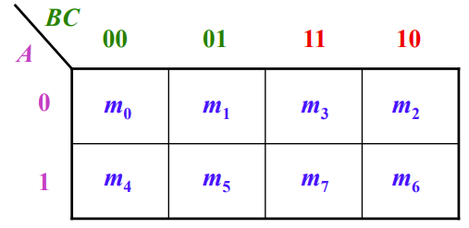

格雷码！

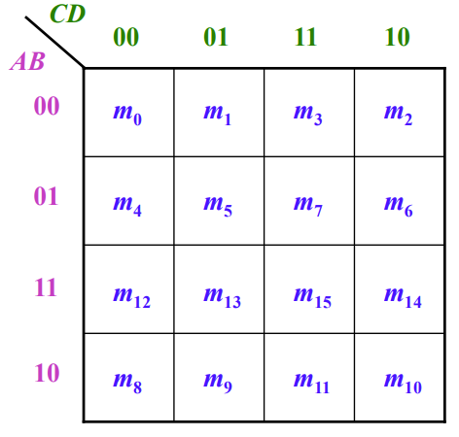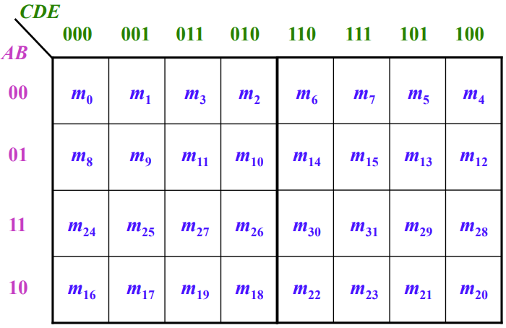

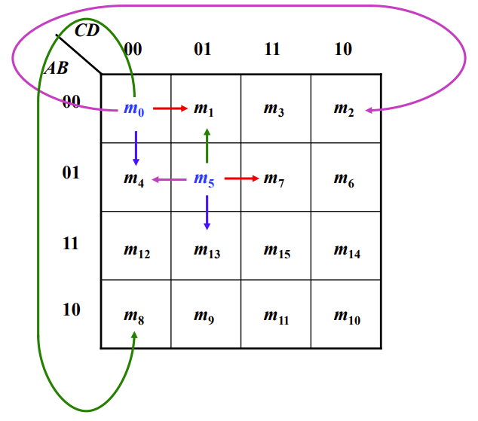Cell Adjacency (单元相邻)：（四角也相邻）

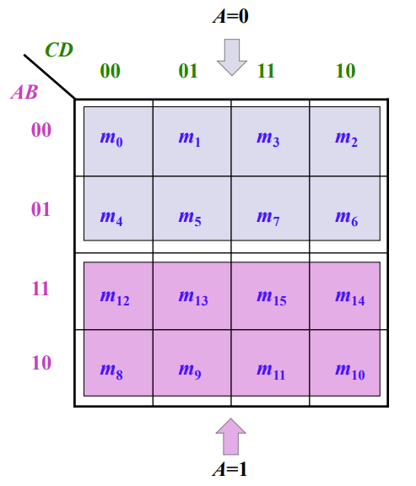

# 4.9 Karnaugh Map SOP Minimization

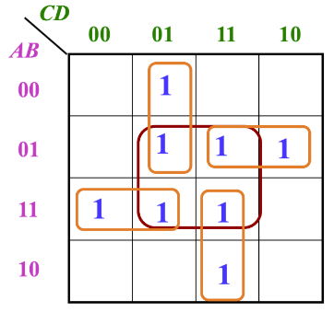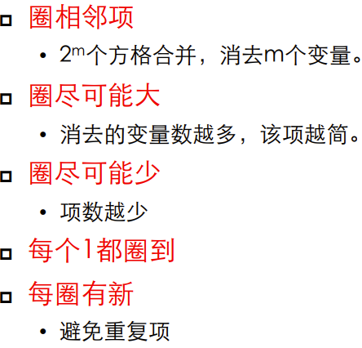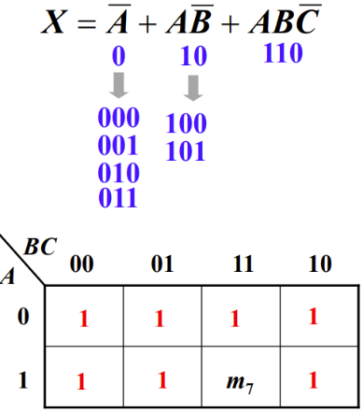

中间4个1没有新

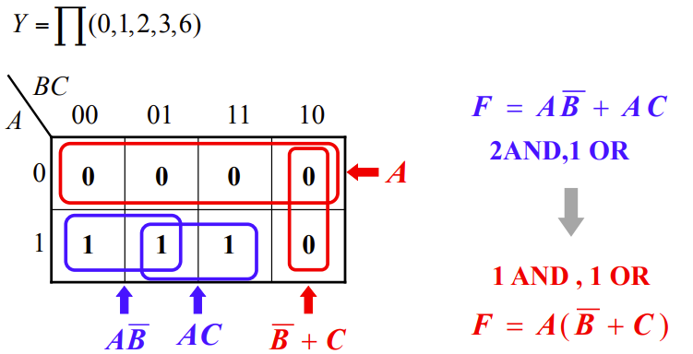

取0或者1得出相同答案

“don’t care” terms:

A combination of input literals that can be used as a 1 or a 0 on Karnaugh map.

Two cases:

• Can not occur 例如BCD码后6个

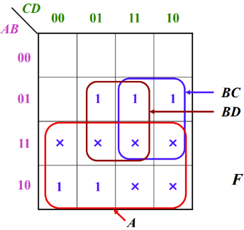• Can occur but we don’t care the value 例如：

不用把所有x都圈进去，圈x的目的是圈出更大的1

例题：

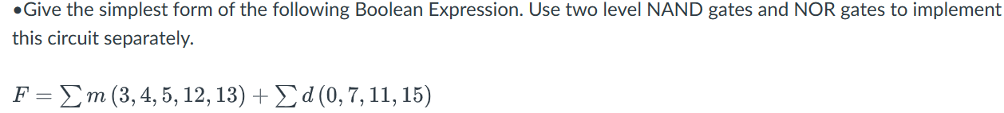

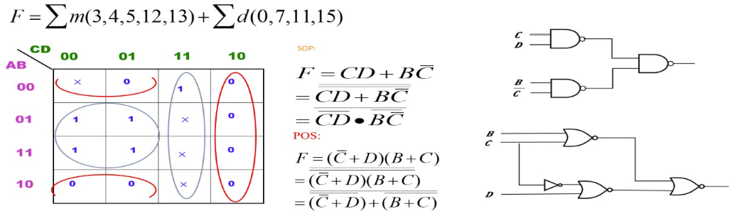

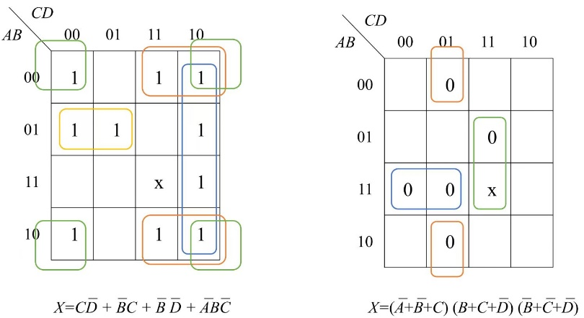

# 6.1 Basic Adders (加法器)

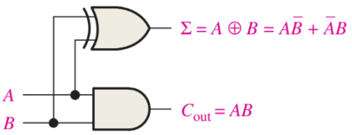1. Half-Adder:

2.Full -Adder: can be used as a BCD-to-binary converter

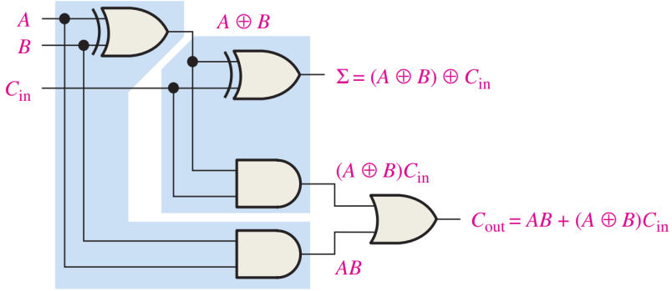

Full-adder implemented with two half-adders: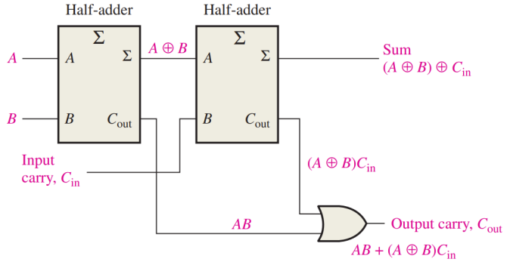

# 6.2 Parallel Binary Adders (并行二进制加法器)

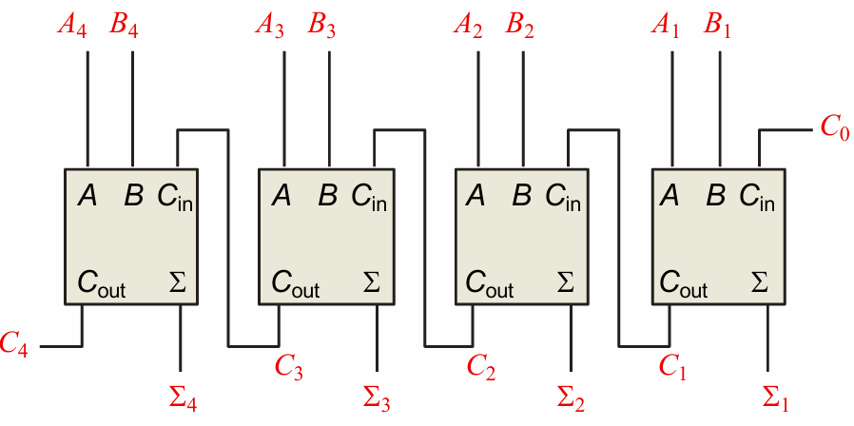

The output carry (C4) is not ready until it propagates through all of the full adders. This is called ripple carry, delaying the addition process.

低位全加器的进位输出与相邻高位全加器的进位输入连接

8-bit adder:

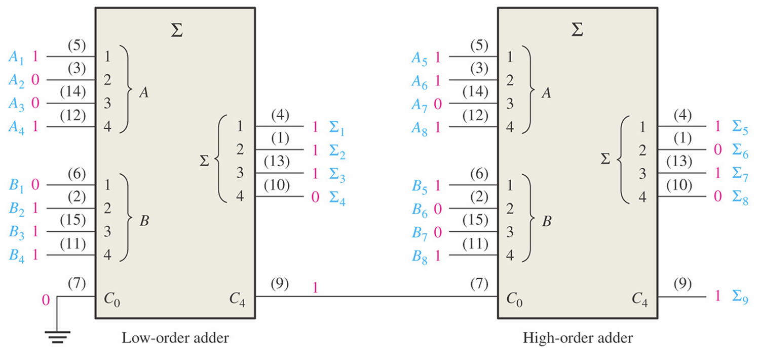

例题：

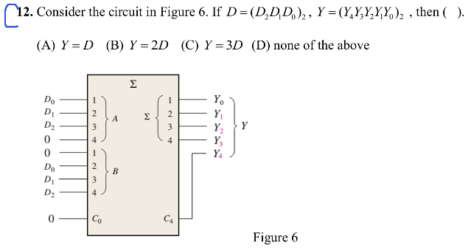

根据进位-> B=2A=2D，相加Y=3D

例题：

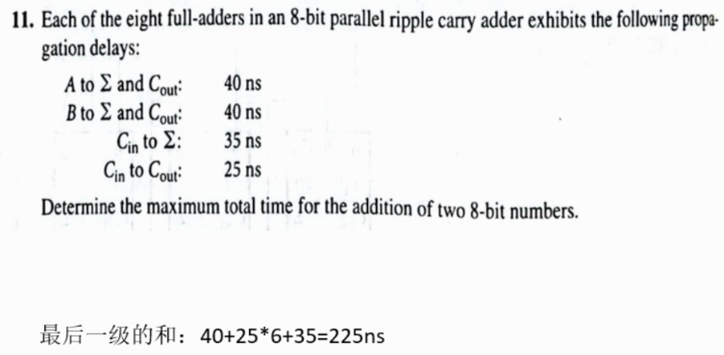

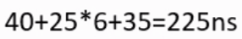

# 6.3 Look-Ahead Carry Adders (超前进位加法器)

output carry by either carry generation or carry propagation

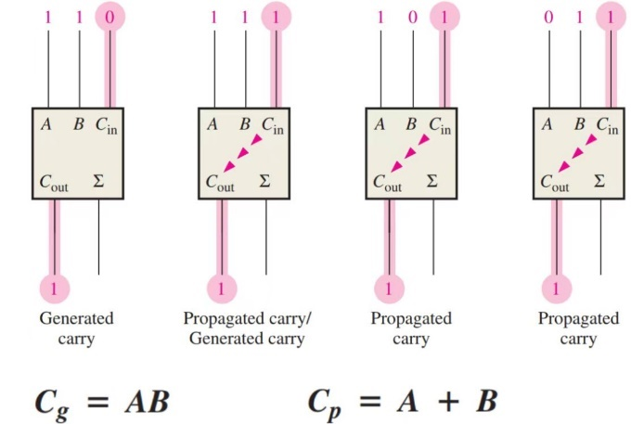

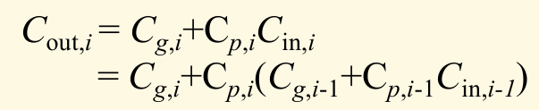

设计一个代码转换电路，将8421BCD码转换成余3码。（余3码是在8421BCD码 上加3构成）:

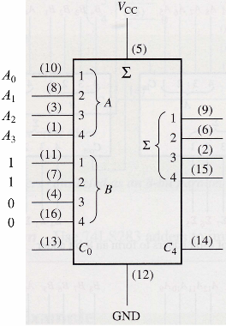

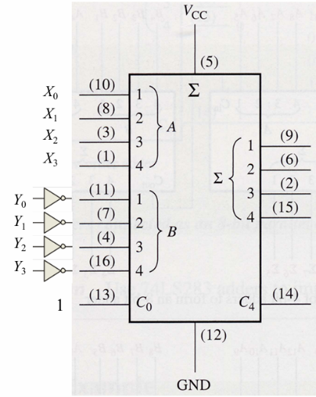

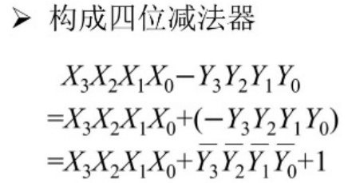

# 6.4 Comparators (比较器)

Basic Comparators (基本比较器)：XNOR

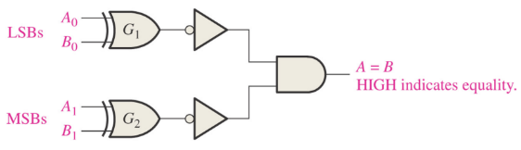Two-Bit Comparators (两位比较器)：

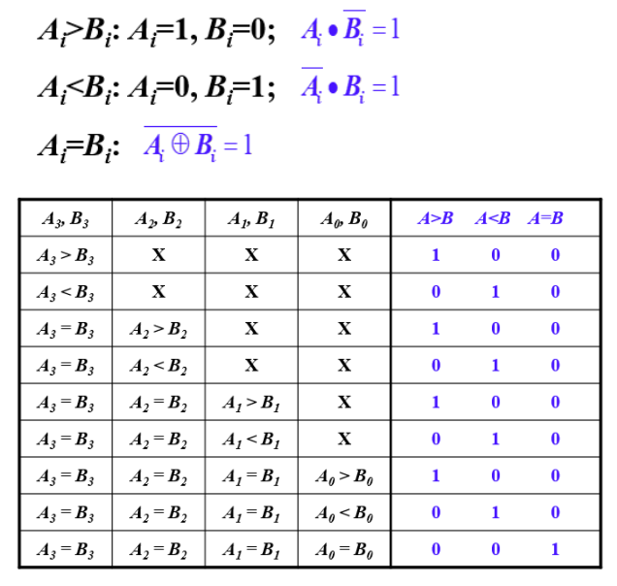4-Bit Comparators (4位比较器)：(从高位比起)

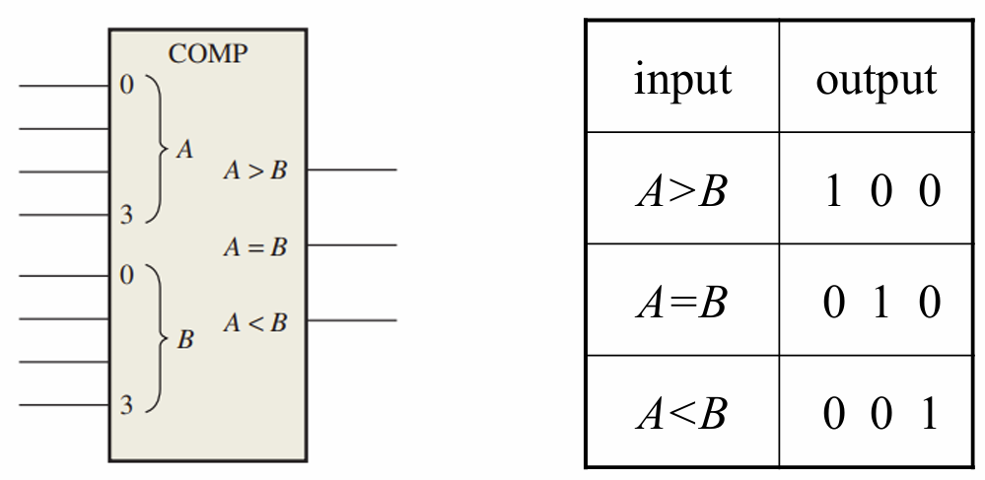

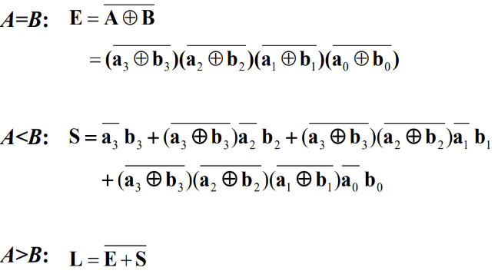

Expansion: 8-bit Comparator：（级联输入）

当高位均相同时比较的结果取决于低位，因此低位的结果应传入高位比较器

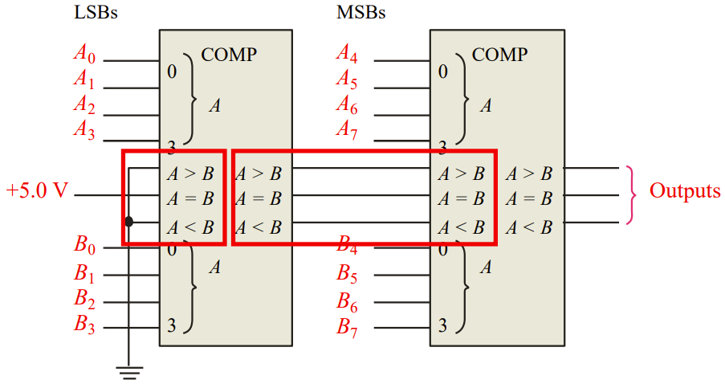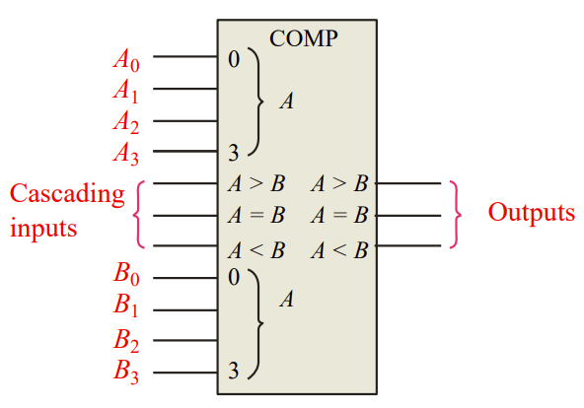

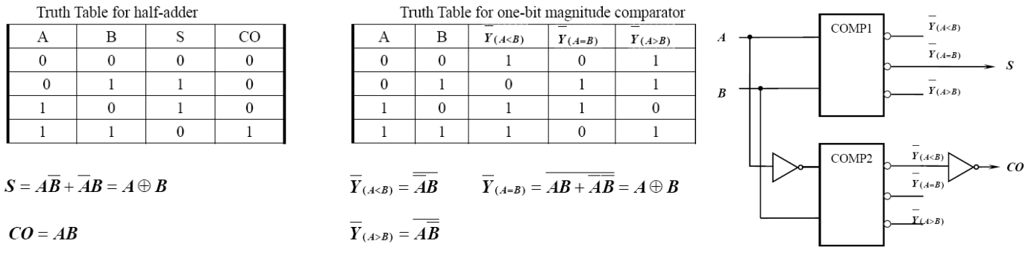

# 6.5 Decoders

detect the presence of a specific combination of bits at its input

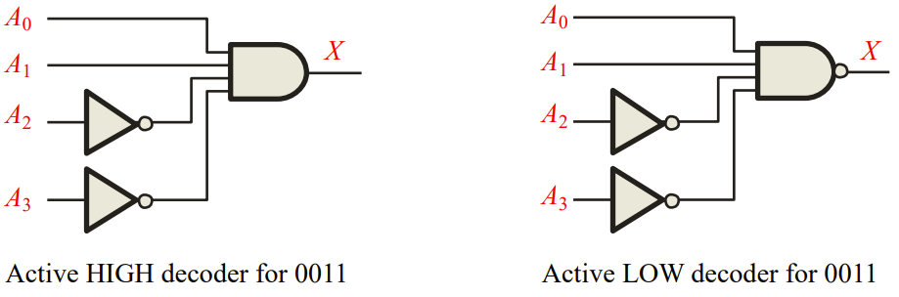

Basic-Decoder (基本解码器)：

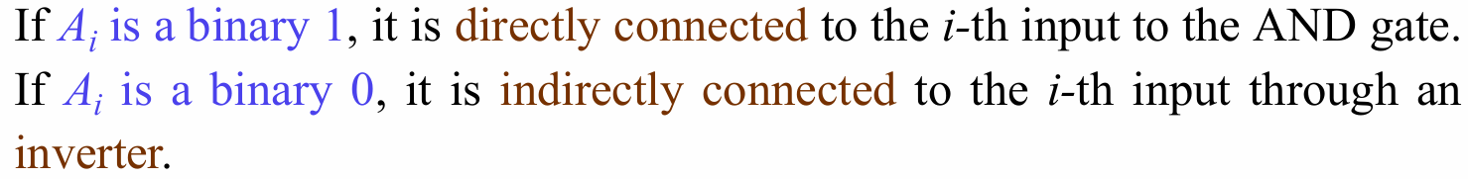

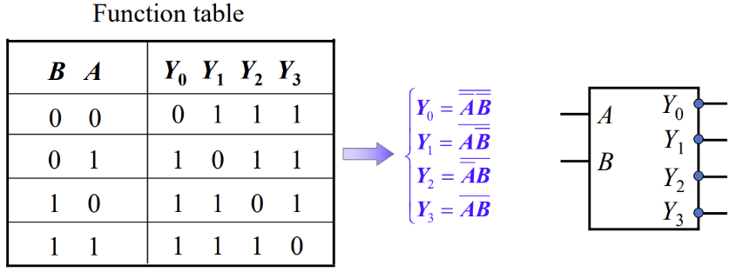2-bit decoder：（LOW）

2-bit decoder with EN (包含使能端的解码器)：（LOW）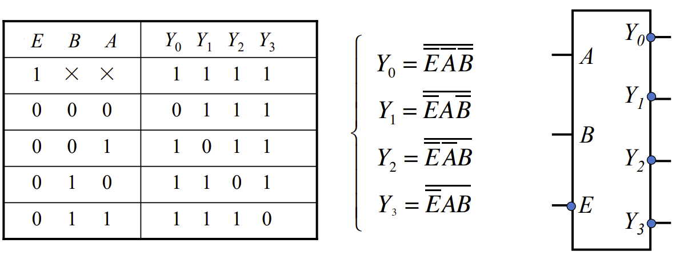

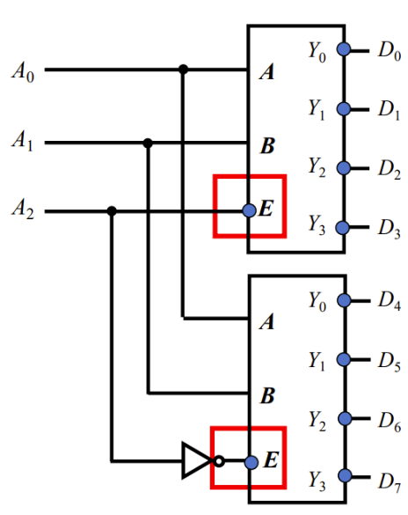Expansion: 3-8 decoder：

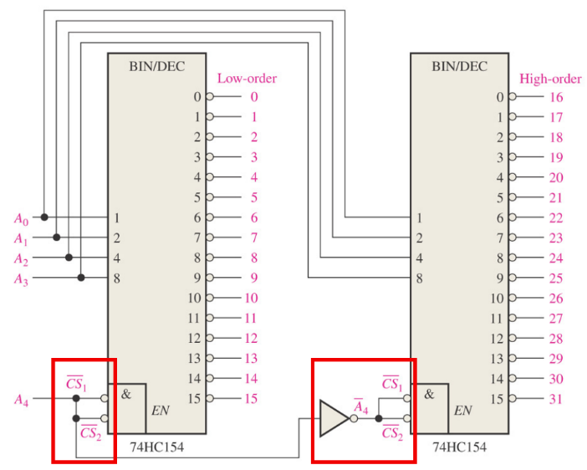Decoder as Minterm Generator：

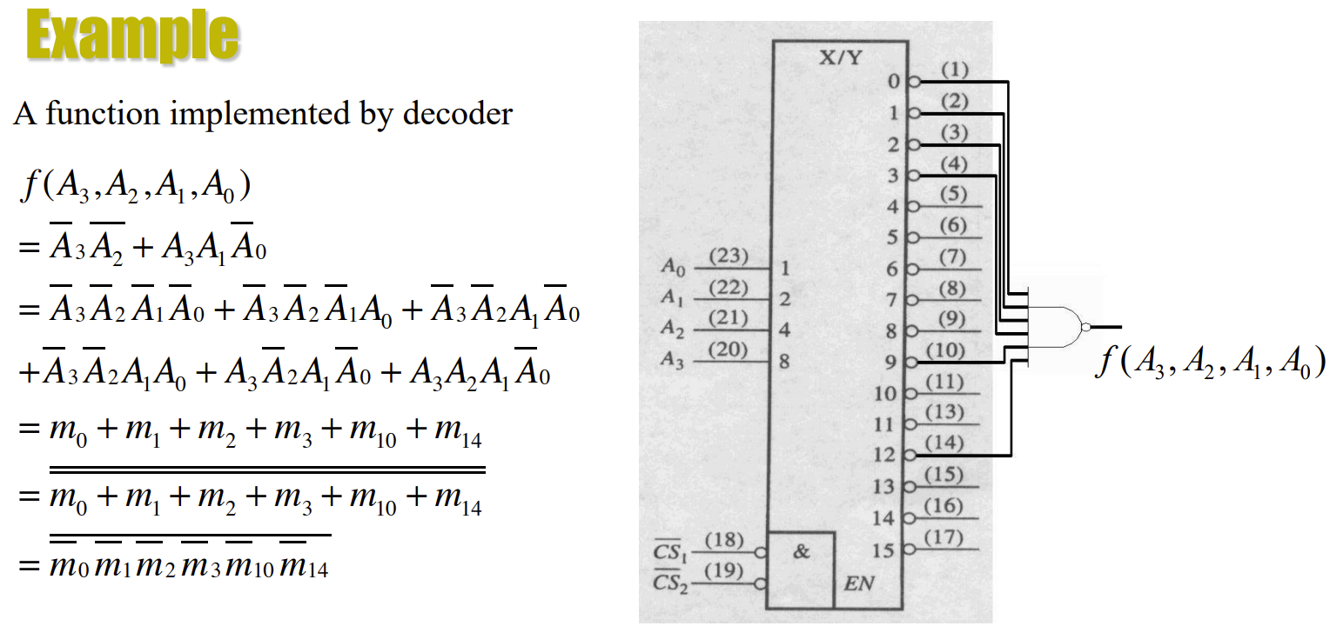

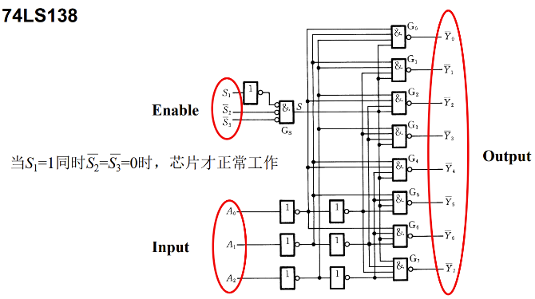3-to-8 decoder: （can also be used as DEMUX）

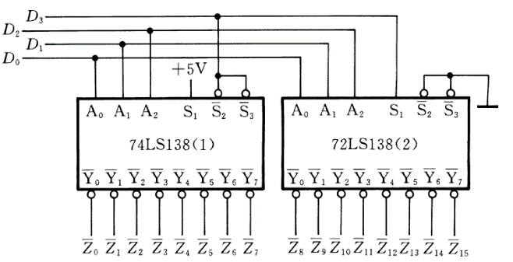Question: 试用两个3线-8线译码器74LS138组成4线-16线译码器，将D3D2D1D0译成16个独立的低电平信号

BCD-to-decimal decoders：accept a binary coded decimal input and activate one of ten possible decimal digit indications. (F) 同一种

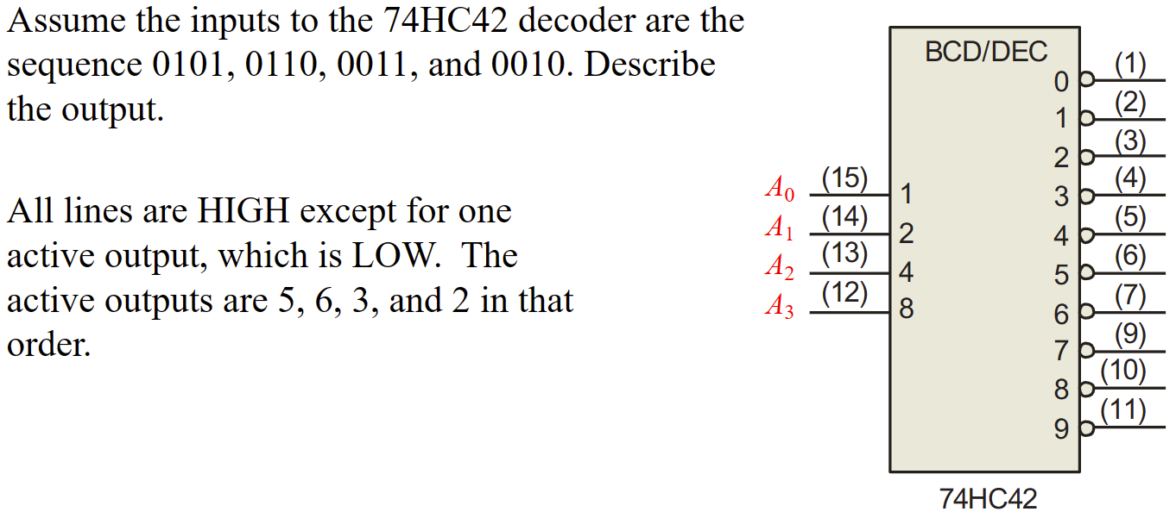

例题：（2021 H卷）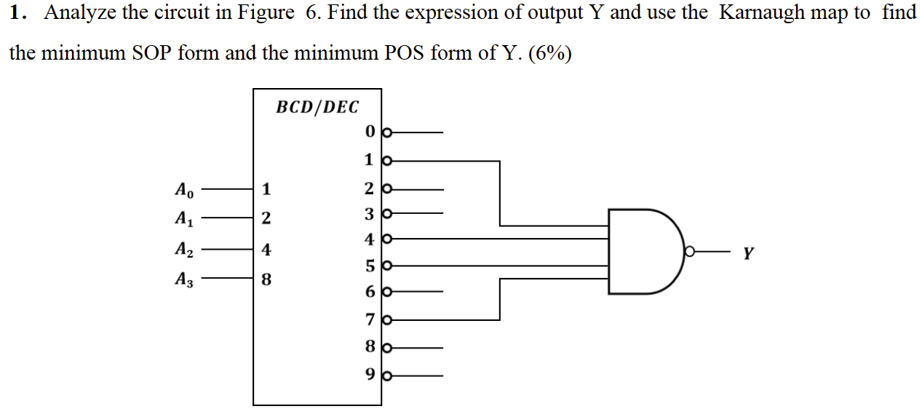

将与非变成非与，和前面的低电平有效消去，变成高电平有效+或门

同时要注意10-15是无关项

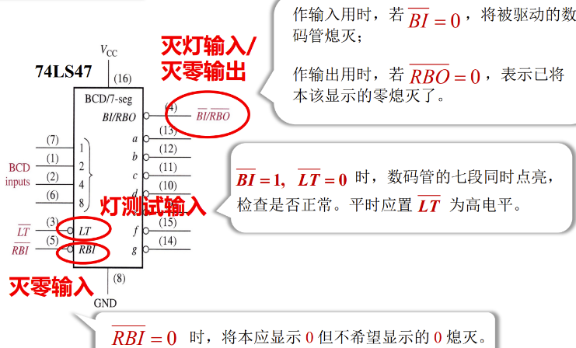The BCD-to-7-Segment Decoder/Driver:

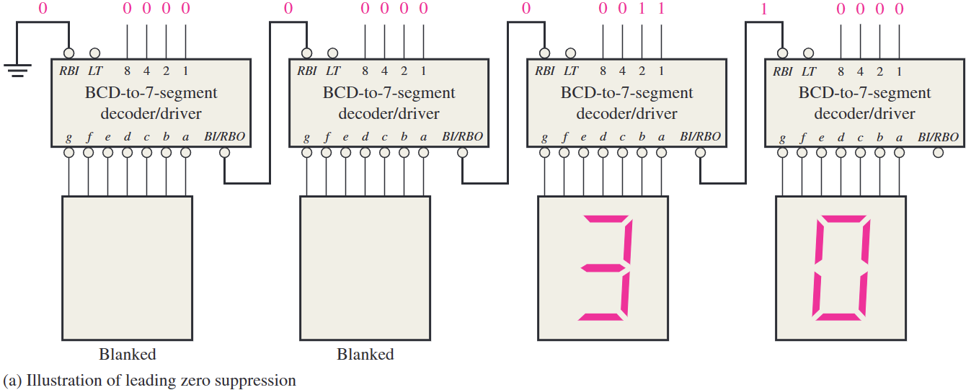

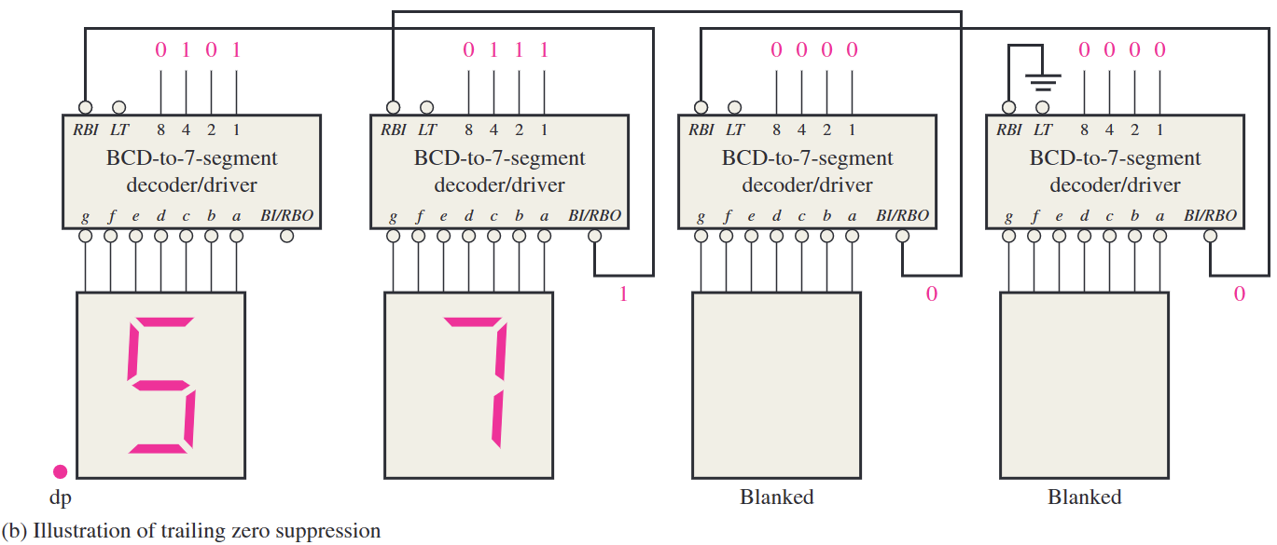

若输入均为0，也需要显示一个0——断开最后一个BI/RBO与RBI连接，RBI接VCC

# 6.6 Encoders (编码器)

将输入的高低电平编辑成对应的二进制码

A 0-digit input is not needed because the BCD output are all LOW when there are no active inputs.

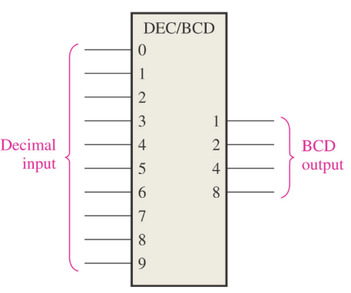The Decimal-to-BCD Encoder:

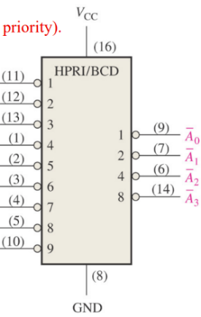The Decimal-to-BCD Priority Encoder (含优先级的): more than one inputs, produce a BCD code corresponding to the highest-order decimal digit input.

1000

8-line-to-3-line Encoder (Priority): 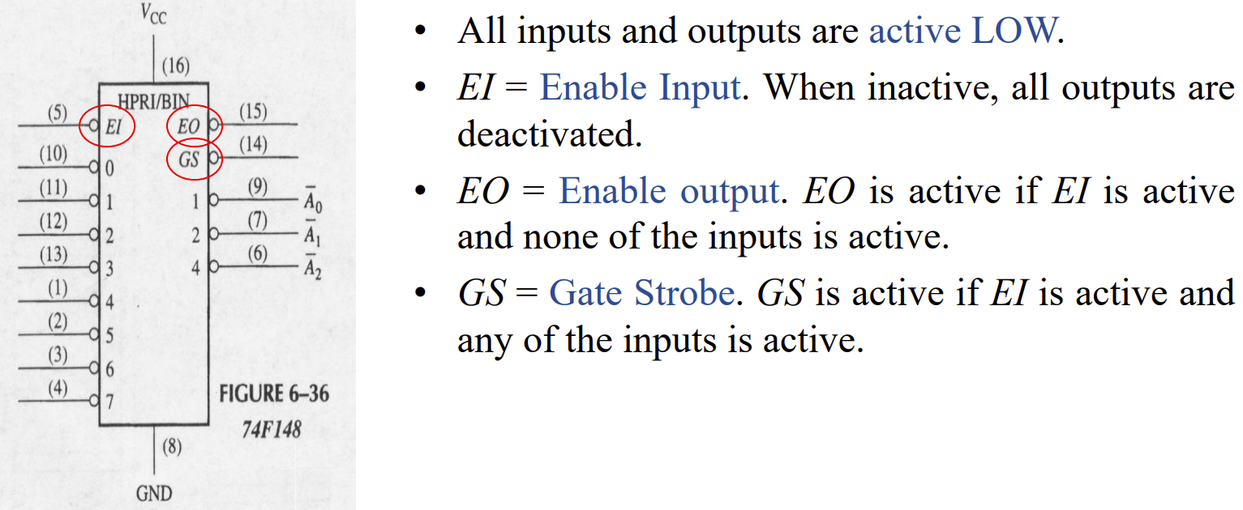

Expansion: Priority Encoder for 16 Bits:

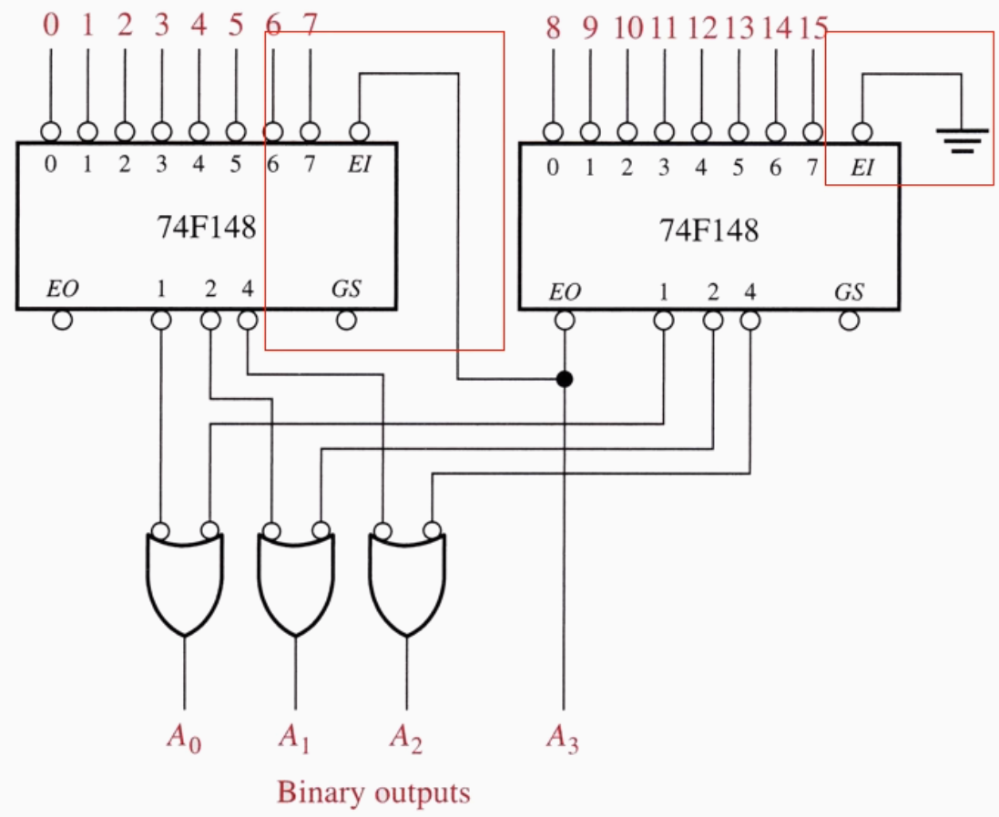

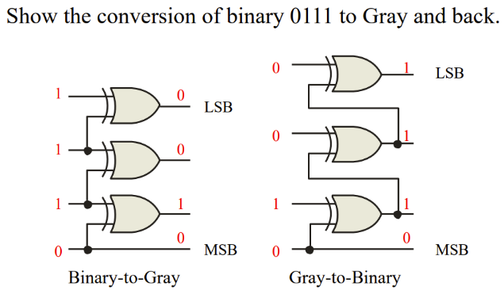Code converters:

# 6.8 Multiplexers/Data Selectors (多路复用器/数据选择器）

several data input lines and a single output line

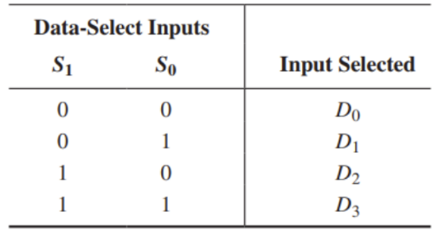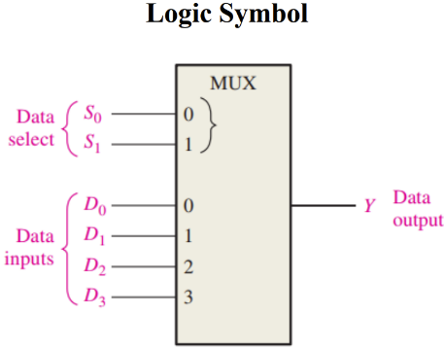

74HC157A: Four separate 2-input multiplexer：

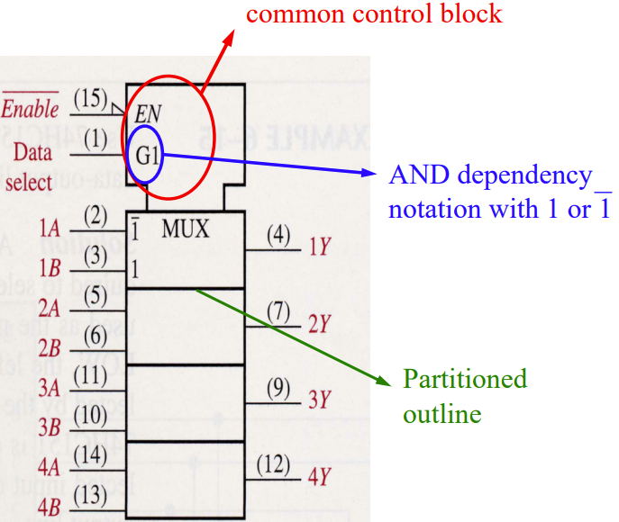

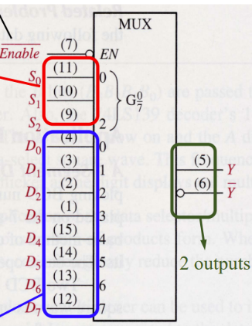74HC151: 1-of-8 multiplexer：

Expansion: use 74HC151 to multiplex 16-inputs：

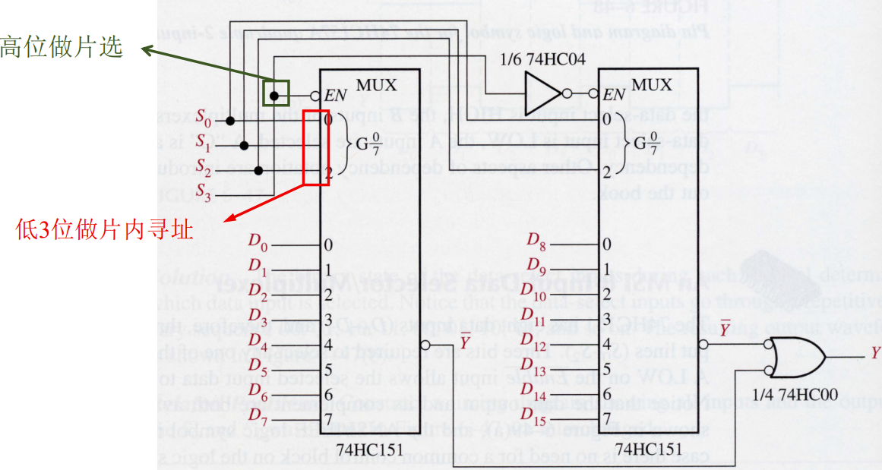

Expansion: 32-inputs multiplexer：

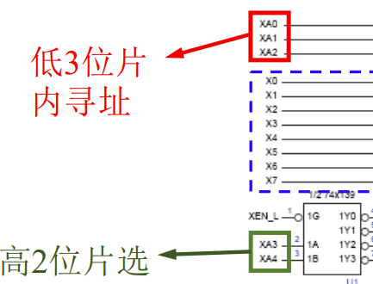

Multiplexer as Logic Function Generator：

第一种 3- variable logic function；(3个变量连接选择输入，数据输入与真值表输出对应)

即相当于把逻辑电路变成标准的SOP表达式，出现的组合的D记为1，其余记为0

第二种 4-variable logic function generator by the utilization of one of the bits in conjunction with the data inputs（3个变量连接选择输入，1个变量连接数据输入)

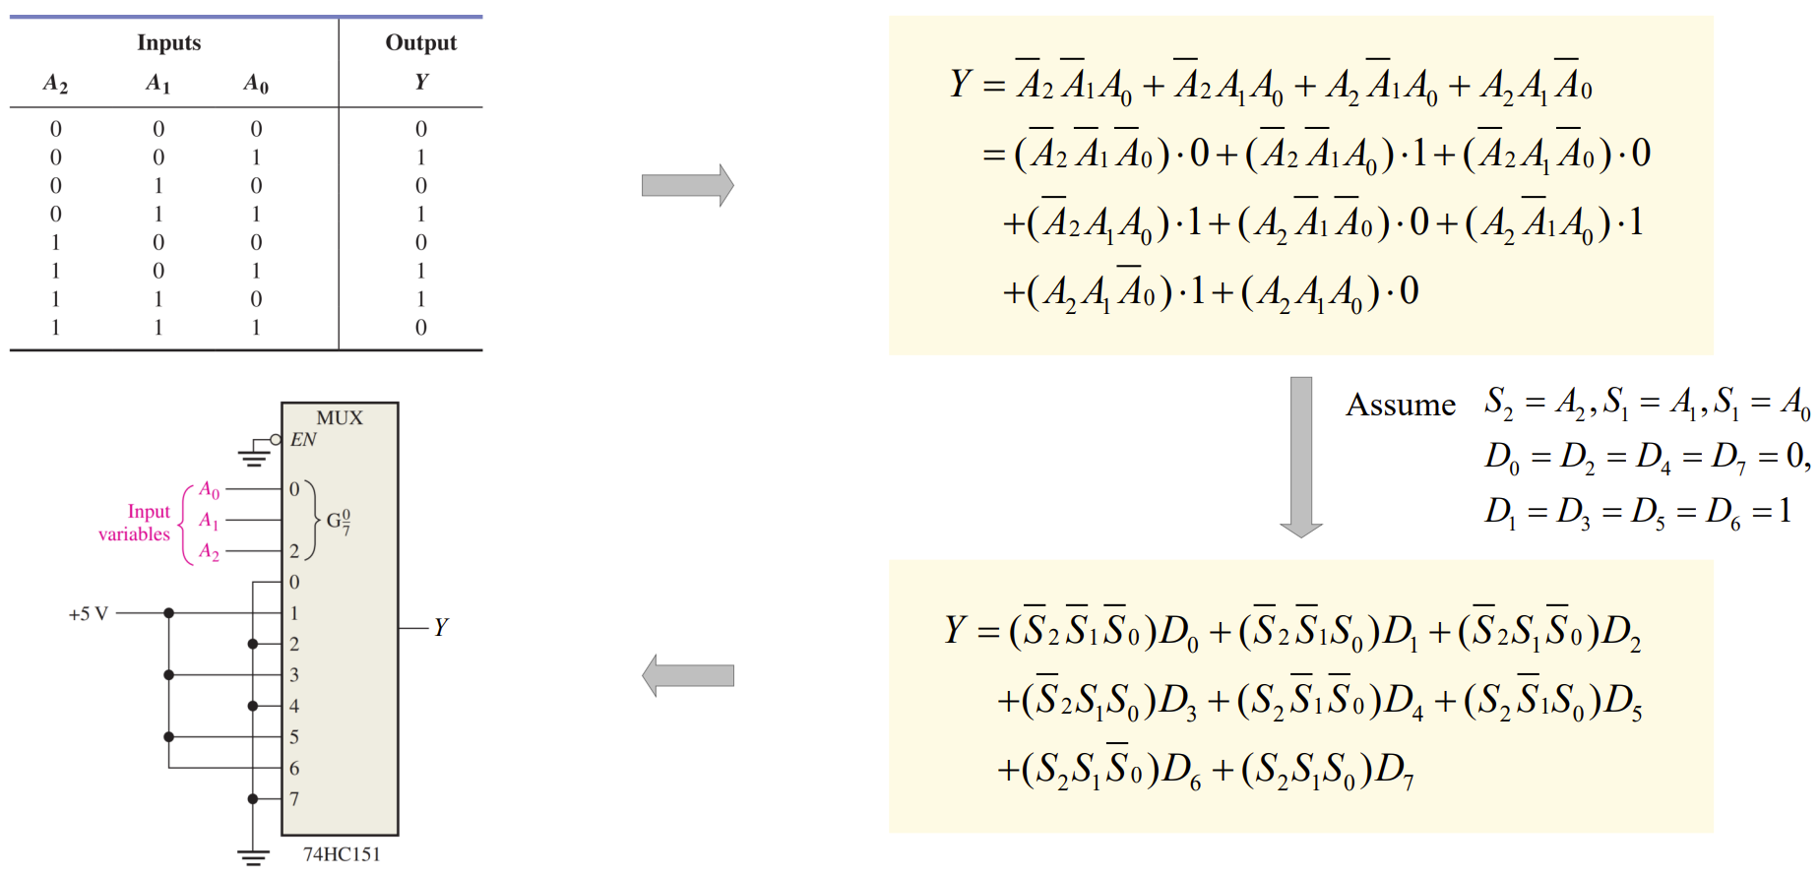

例题：（2021 H卷）

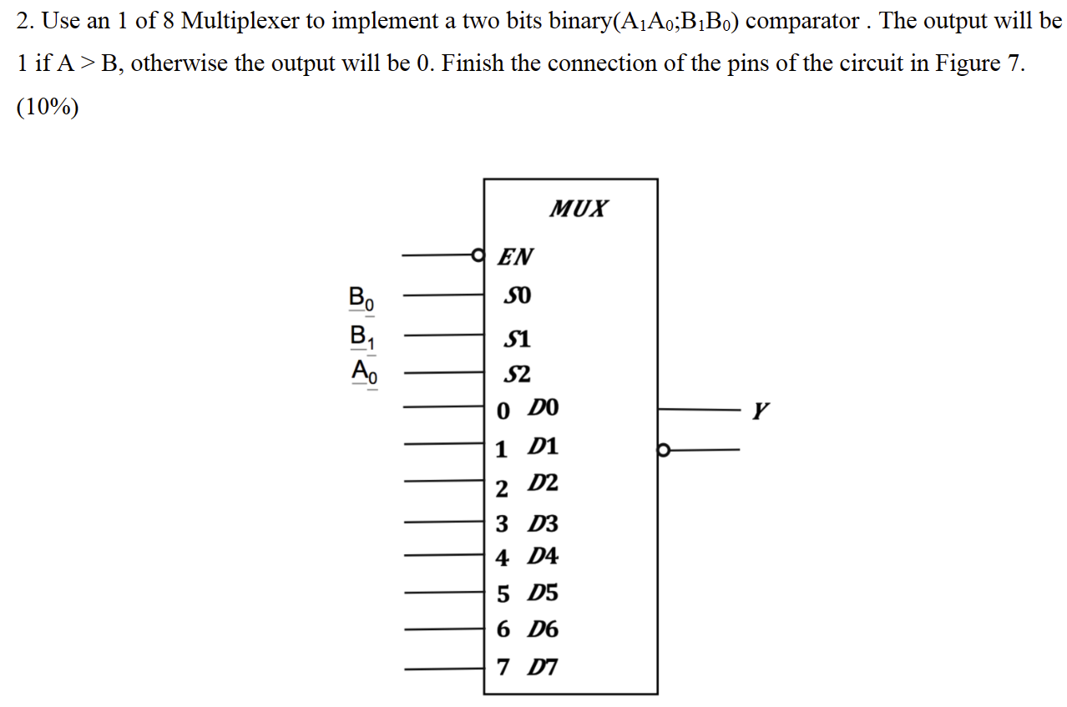

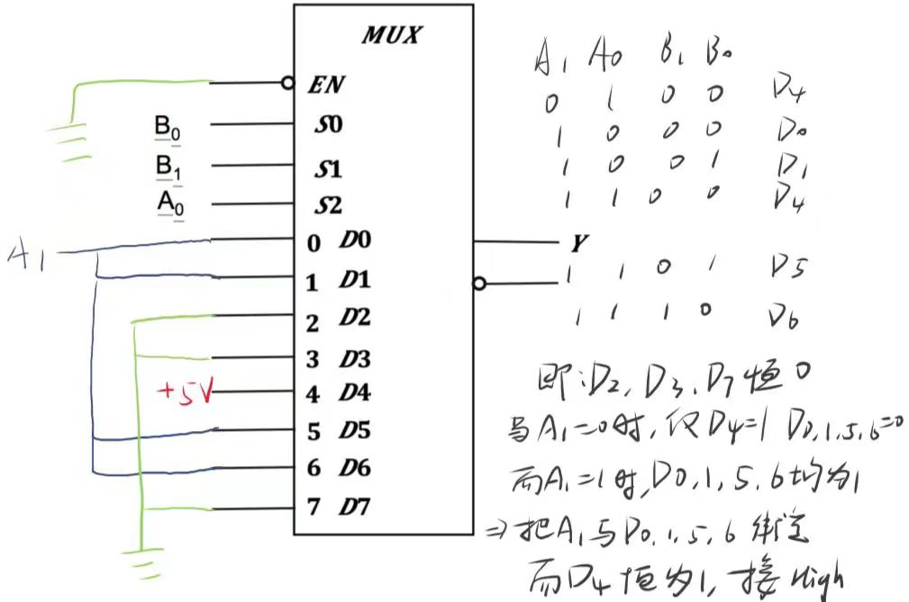

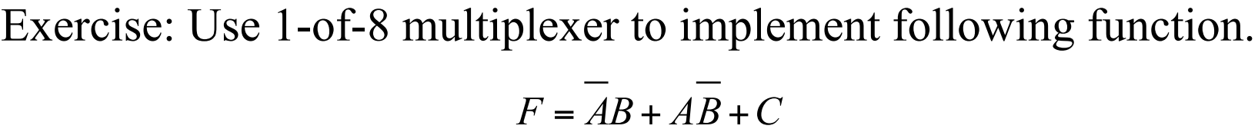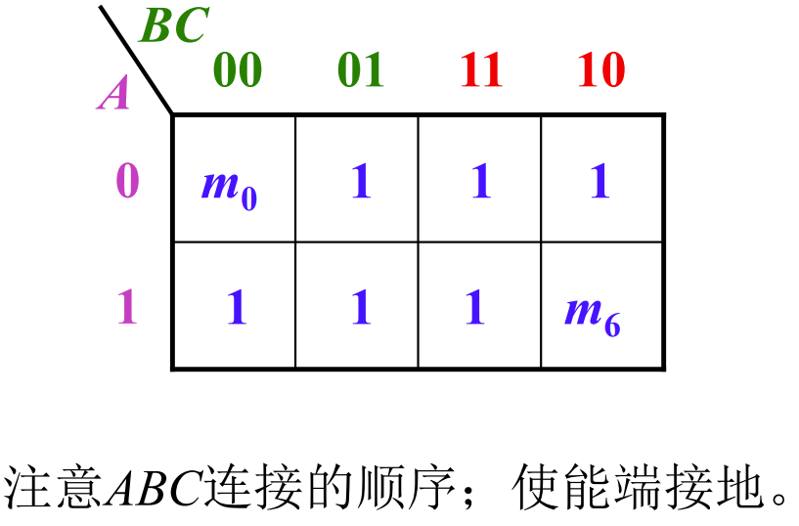

若如图顺序，则连接方式：MSB到LSB分别为ABC；不同的连接方式ABC对应的D不同

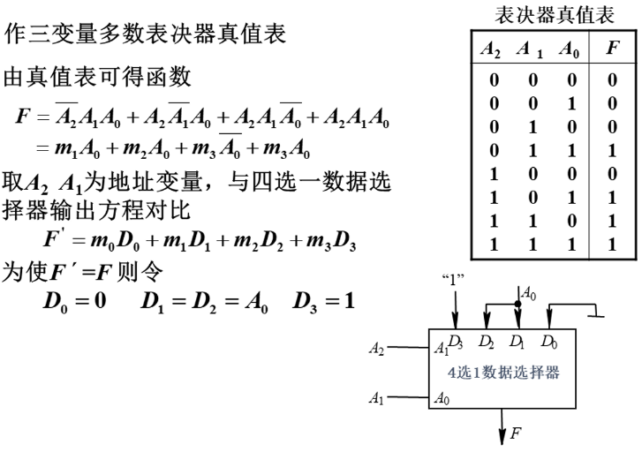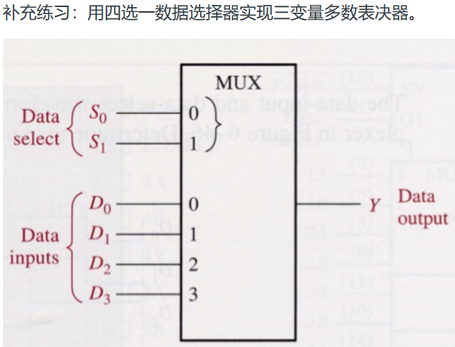

# 6.9 Demultiplexer (多路分用器/数据分发器）

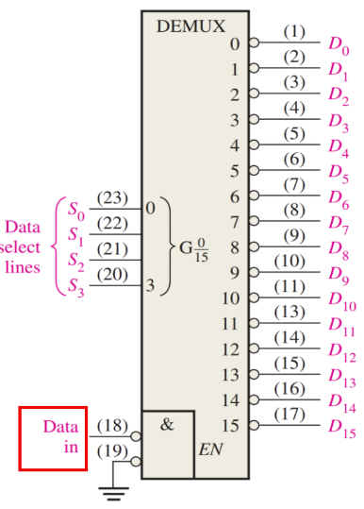1-to-4 Demultiplexer：

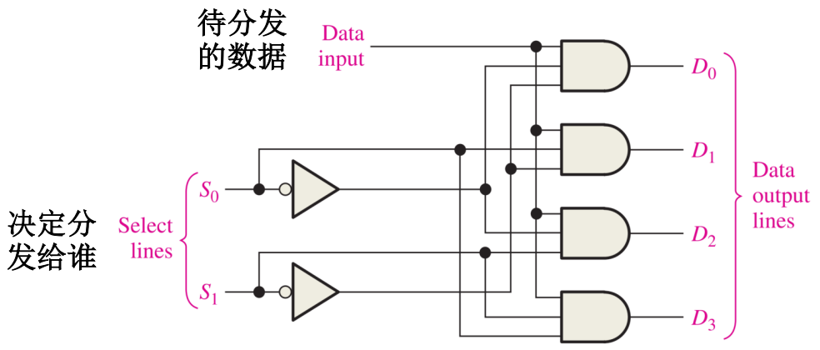

Decoder Used as Demultiplexer:

解码器输入端连接数据选择输入,某一使能端连接数据输入

将data in 的数据从以s0-s3确定的Dn传送出去

# 6.10 Parity Generators/Checkers (奇偶校验)

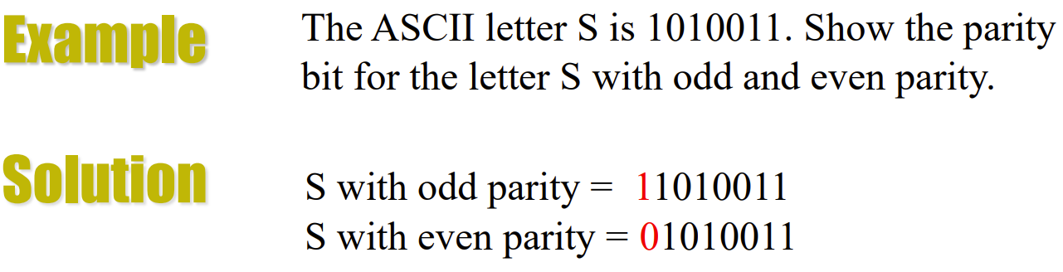

Can only detect single bit errors

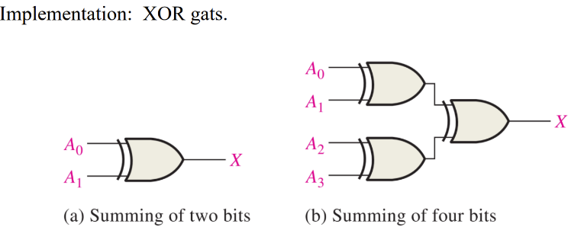

加起来是奇数则有奇数个1

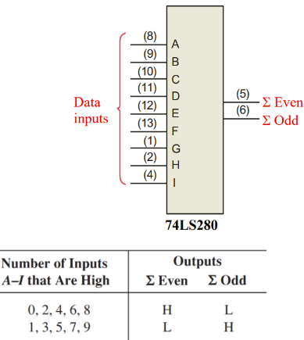The 74LS280 can be used to generate a parity bit or to check an incoming data stream for even or odd parity.

Checker:看even和odd哪个是高电平

Generator：作为校验器时，to generate even parity, the parity bit is taken from the odd parity output.

# 补充：Logic Hazards

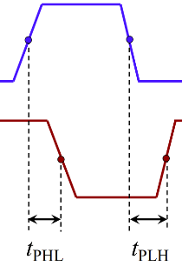Definition of Propagation Delay Time tP:

the time interval between a specified reference on the input pulse and a corresponding reference point on the resulting output pulse.

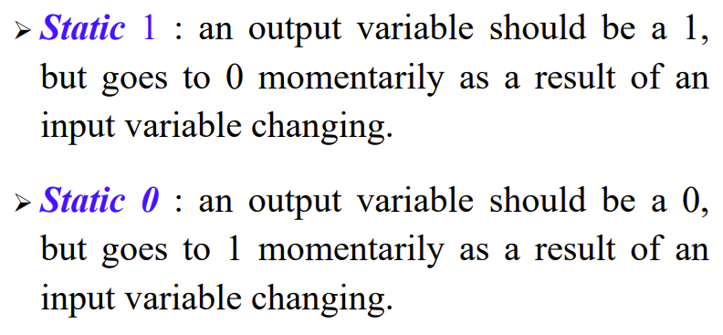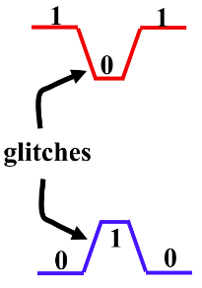

Potential : the circuit simplified as follows $A+\overline{A}=1$ or $A\overline{A}=0$

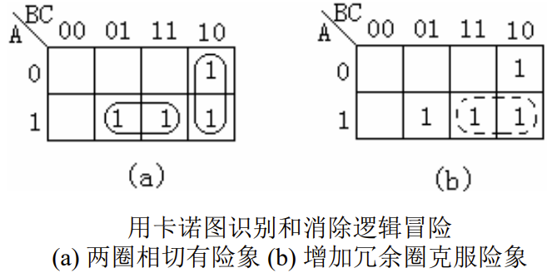消除竞争冒险：采用修改逻辑设计增加多余项

# 7.0 Flip-Flop (触发器)

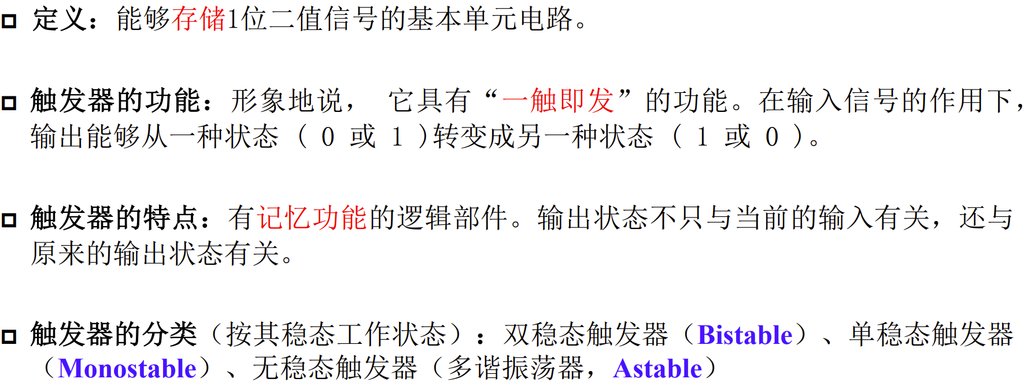

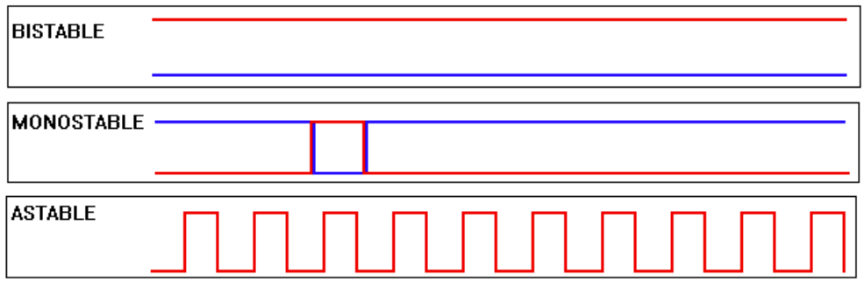

# 7.1 Latches (锁存器)

S-R Latches (置位-复位锁存器)：

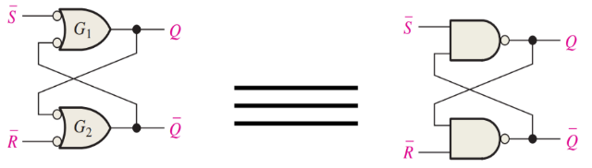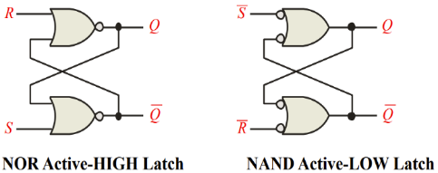

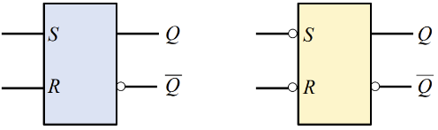

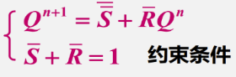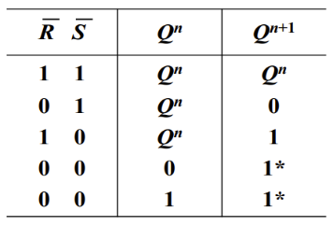

状态转换图：

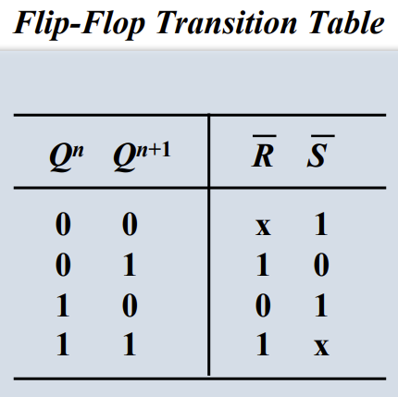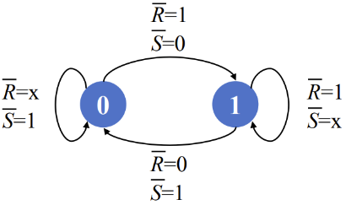

基本S-R锁存器的功能表和特性方程：

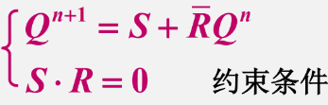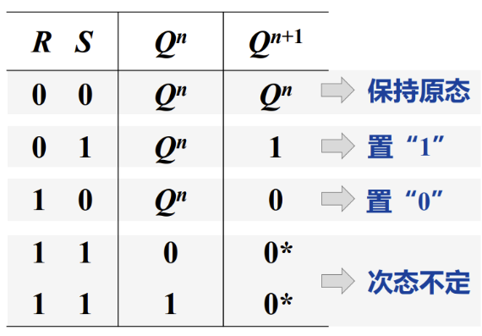

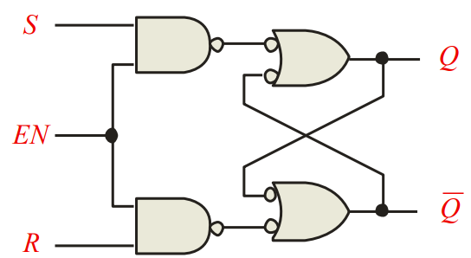Gated Latches (门控锁存器)：

EN端：若从有效电平变成无效，输出仍保持原来的不变

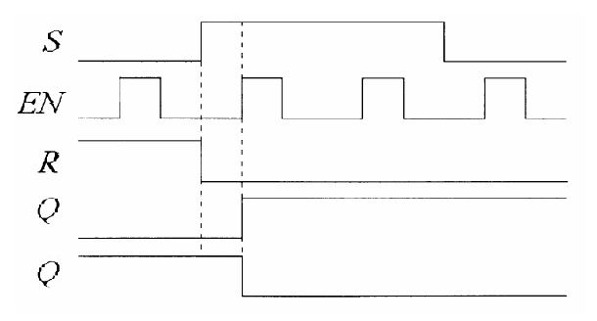

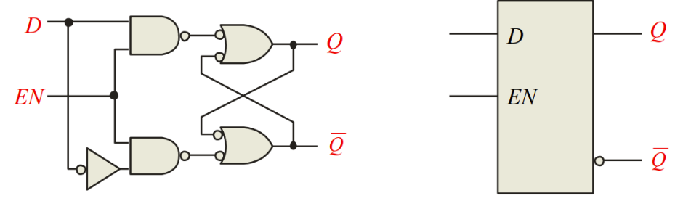D-Latches (门控D锁存器): Q follows D when the Enable is active.

J-K Latch：

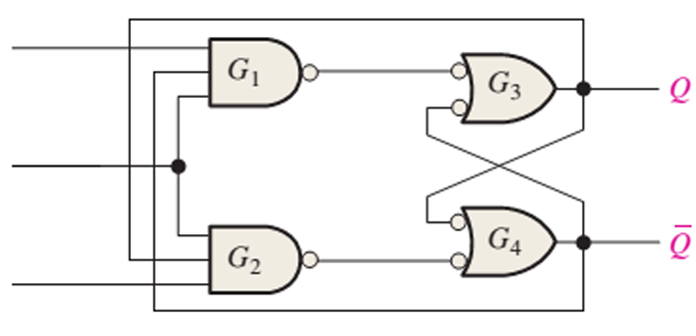

# 7.2 Flip-Flops

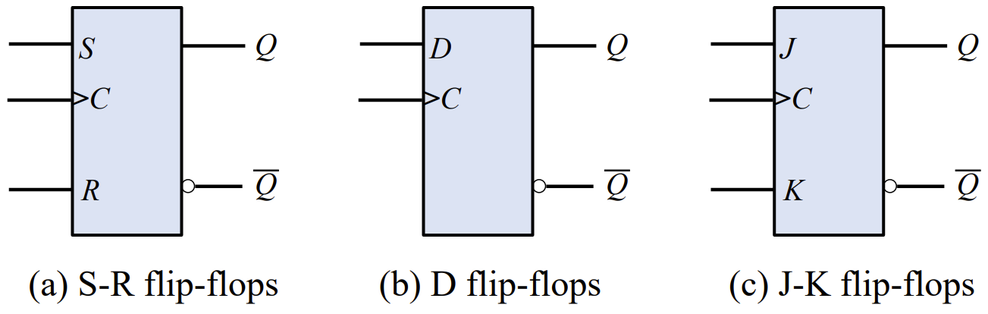

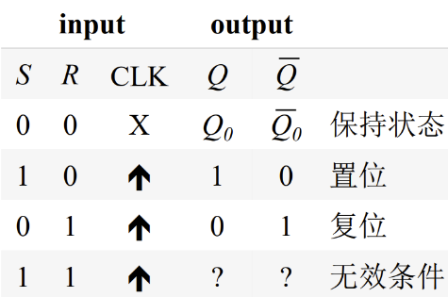

S-R Flip-flops (S-R边缘触发器):

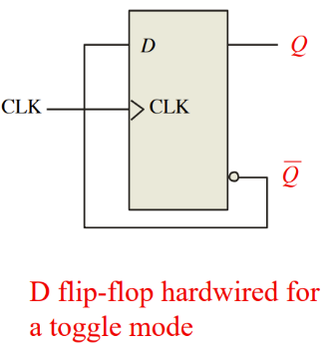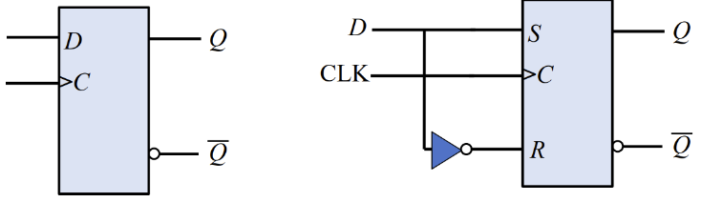D Flip-flops (边缘触发的D触发器):

J-K Flip-flops (边缘触发的J-K触发器):

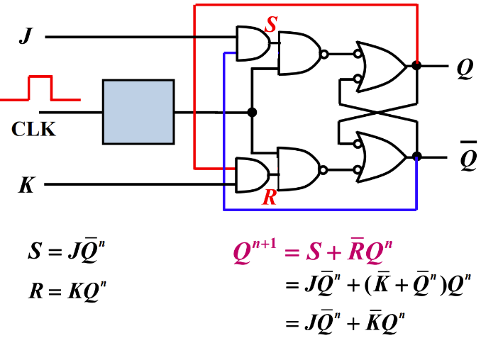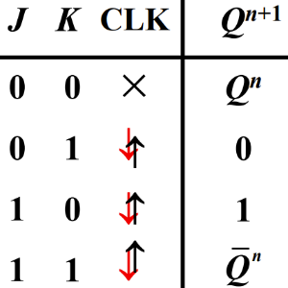

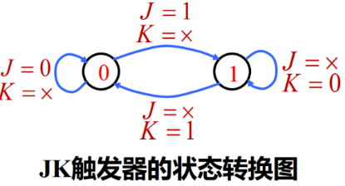

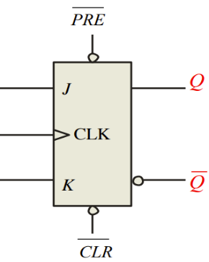Asynchronous Preset and Clear Inputs:

当异步置位或复位输入端出现有效电压信号，则不管J、K端输入如何，触发器被立即置位或复位。(不受时钟控制)

补充：

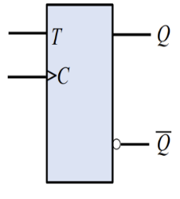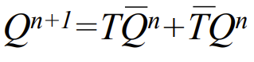T Flip-Flops：

当T=1时，每来一个时钟脉冲，状态翻转一次

当T=0时，每来一个时钟脉冲，状态不变

T’ Flip-Flops：每来一个时钟脉冲，状态翻转

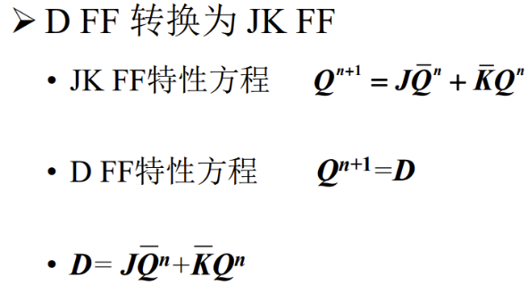触发器逻辑功能的转换：

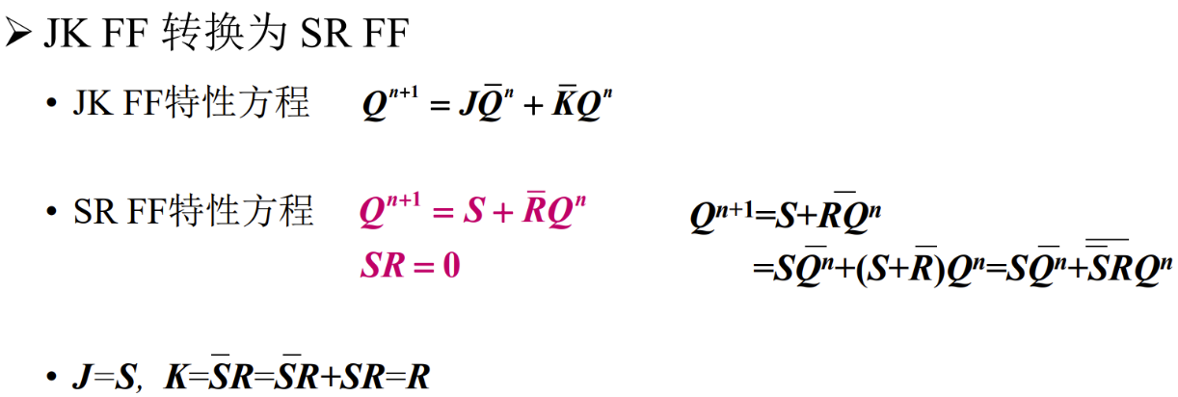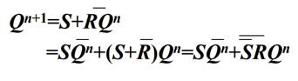

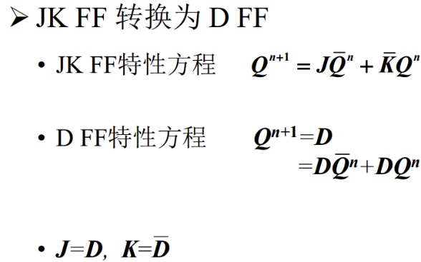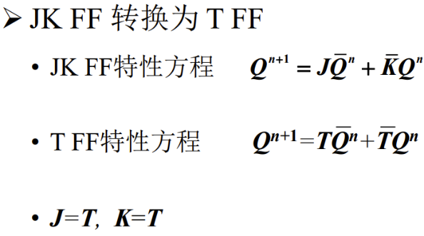

# 7.3 Flip-Flop Operating Characteristics

Propagation delay time：

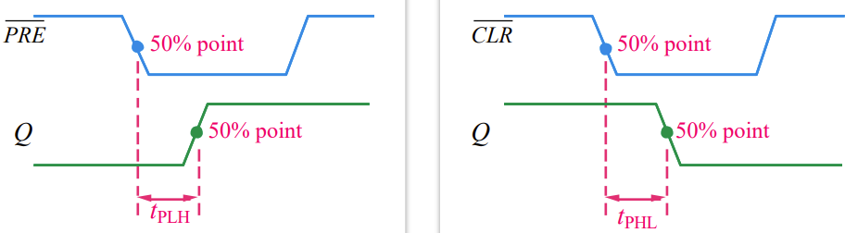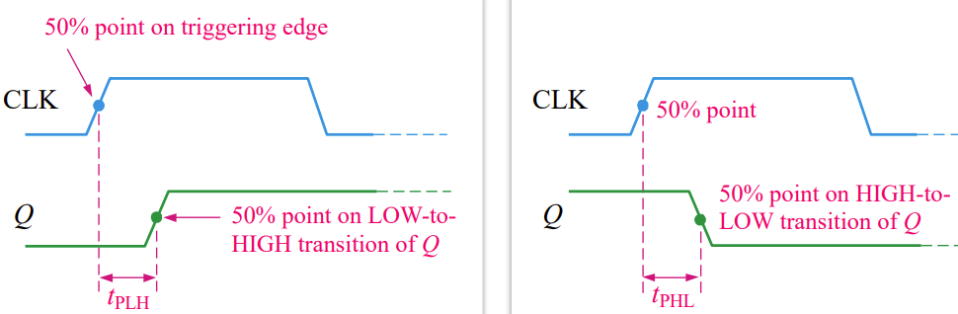

Set-up time and hold time：

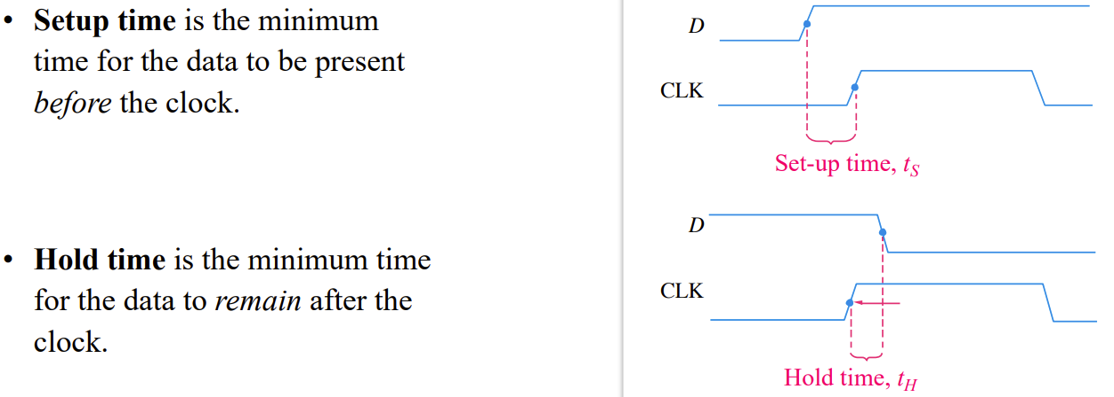times required before and after the clock transition that data must be present to be reliably clocked into the flip-flop.

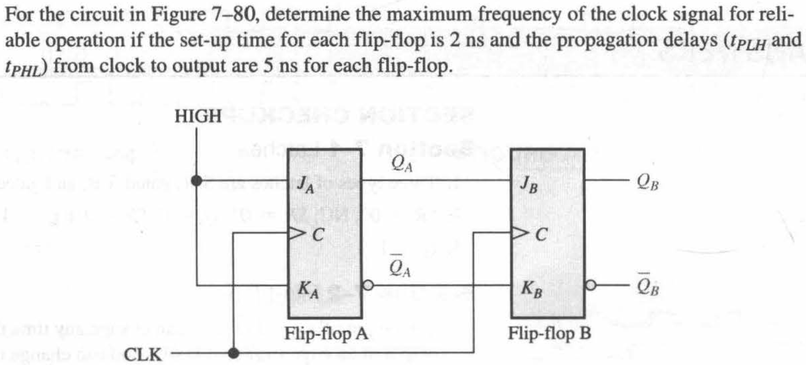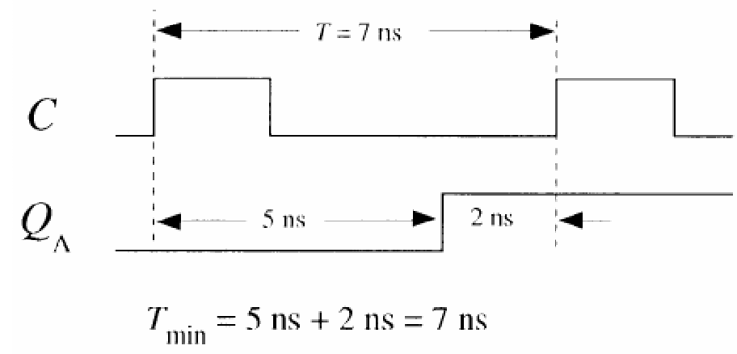

# 7.4 Flip-Flop Applications

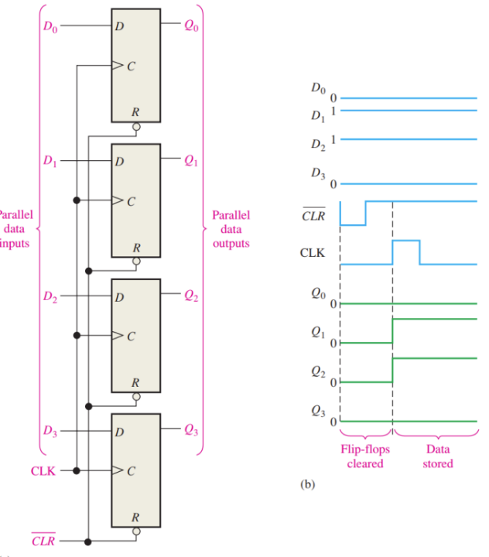Parallel Data Storage:

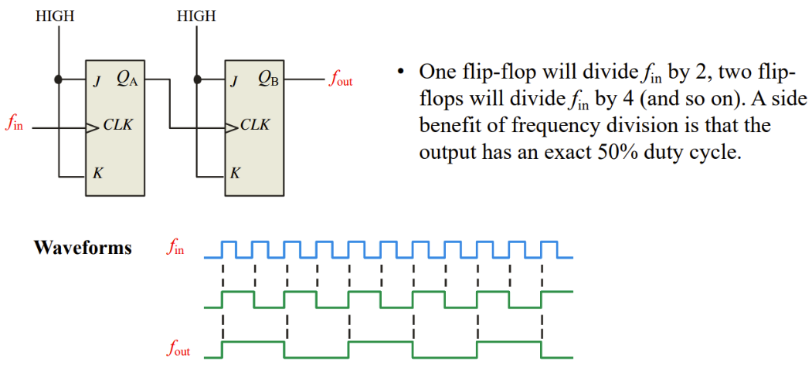Frequency Division:

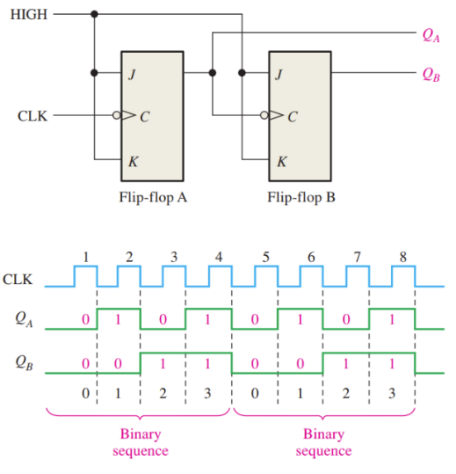Counting:

# 7.A Schimitt Trigger (施密特触发器)

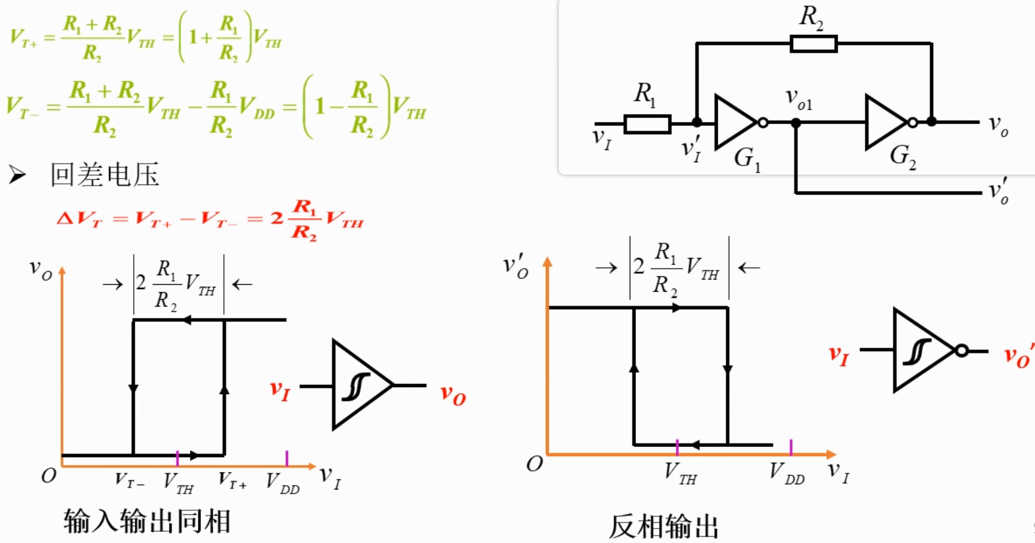

特点：

(1) 输入信号上升和下降过程中电路状态转换对应的触发电平不同

(2) 输出信号的边沿很陡

应用：波形变换、脉冲整形

(1) 可将边沿变化缓慢的波形整形为边沿陡峭的波形

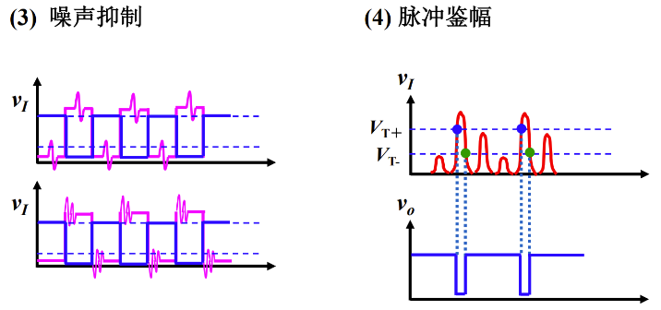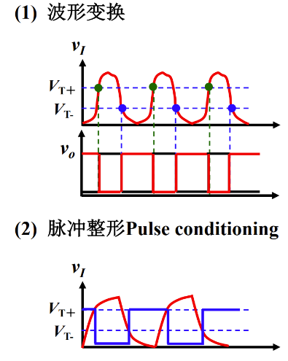(2) 可将加在矩形脉冲高、低电平上的噪声有效地消除

# 7.5 One-Shots (单稳态触发器)

one stable state and one unstable state

When triggered, it goes to its unstable state for a predetermined length of time (determined by an external RC circuit), then returns to its stable state.

**Nonretriggerable One-Shot：**

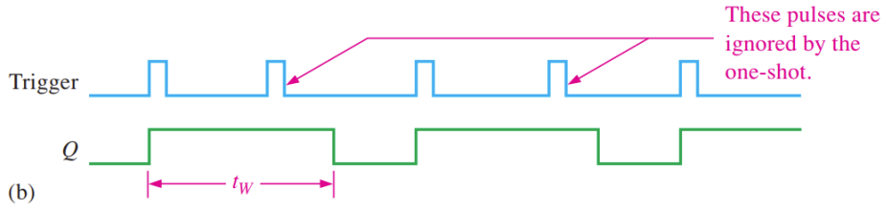

74121 Nonretriggerable One-Shot：

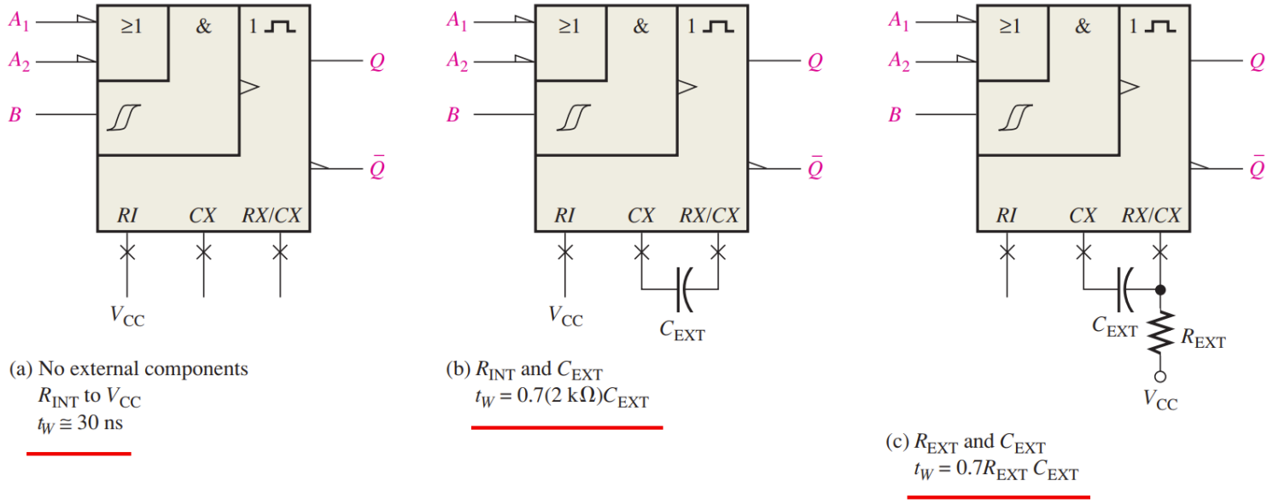

内置2KΩ电阻

[使用文档中的独特引言吸引读者的注意力，或者使用此空间强调要点。要在此页面上的任何位置放置此文本框，只需拖动它即可。]



**Retriggerable One-Shot：**

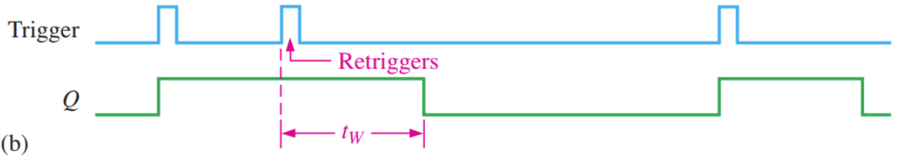

Application: power failure detection circuit

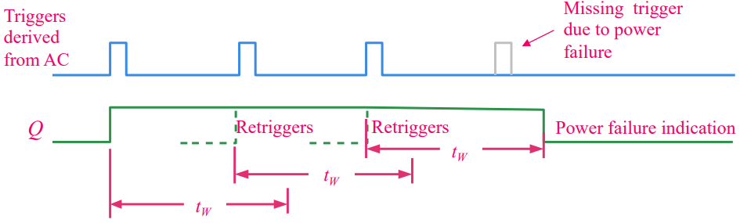

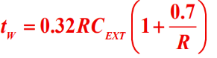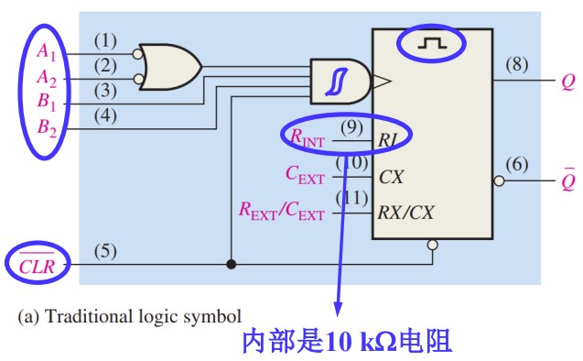 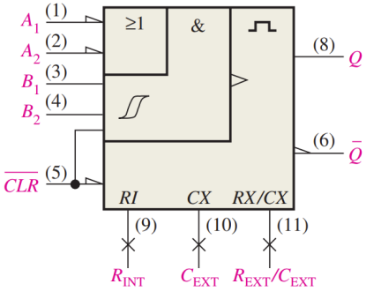

tW≈45ns

例题：





# 7.6 The 555 Timer

Comparator (比较器）：

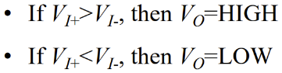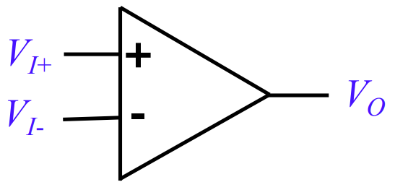

Discharge Transistor (放电晶体管)：

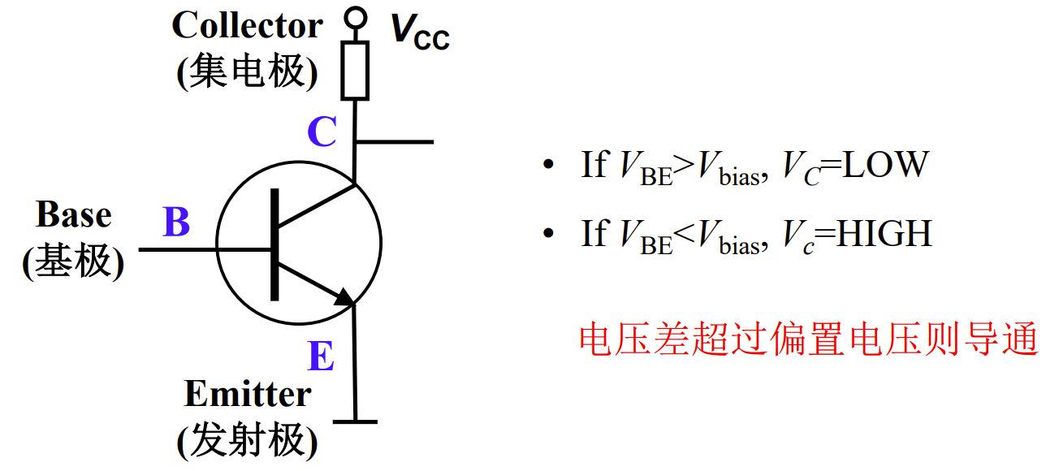

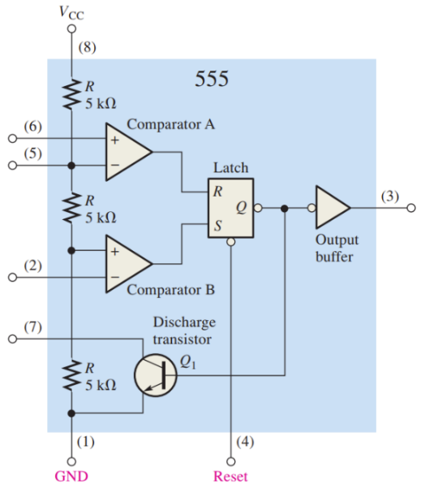

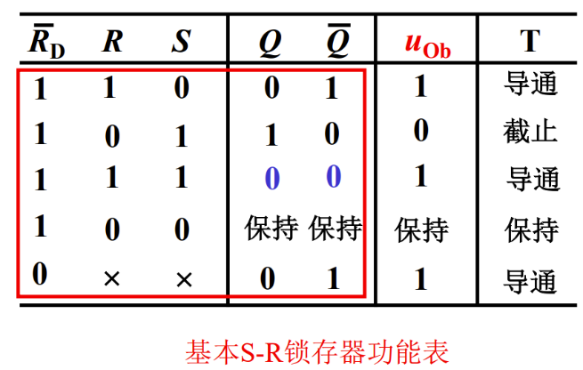

**The 555 Timer as a One Shot：**(Nonretriggerable)

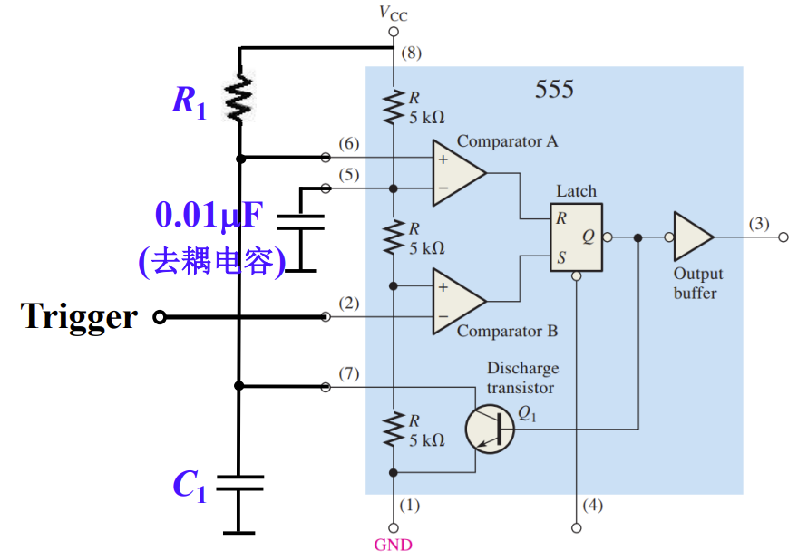

tw=1.1R1C1

**The 555 Timer as an Astable Multivibrator（多谐振荡器）:**

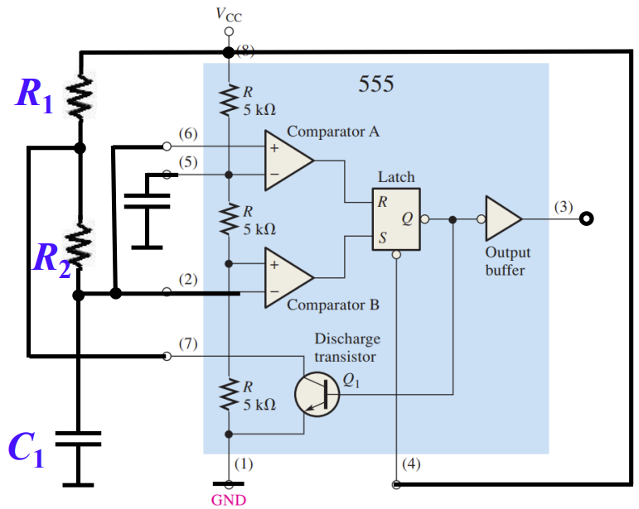

tH = 0.7(R1+R2) C1 tL = 0.7R2C1 T= 0.7(R1+2R2)C1

，恒＞50%

改版：

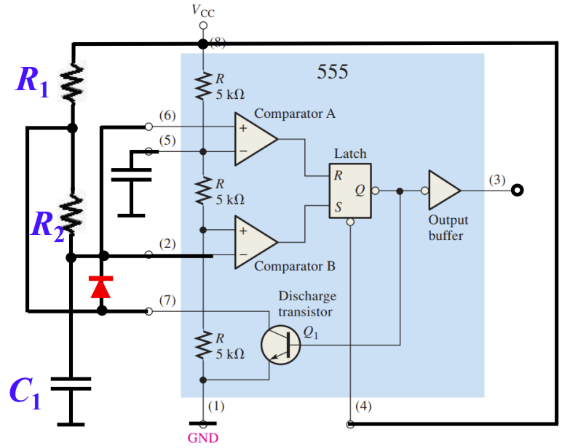

tH = 0.7R1C1 tL = 0.7R2C1 T= 0.7(R1+R2)C1

**The 555 Timer as a Schmitt Trigger：**

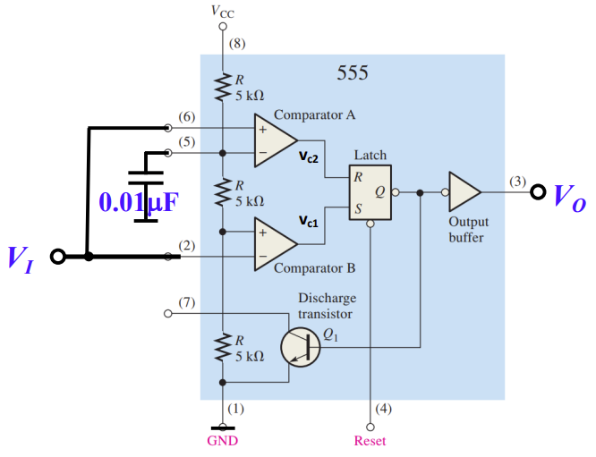

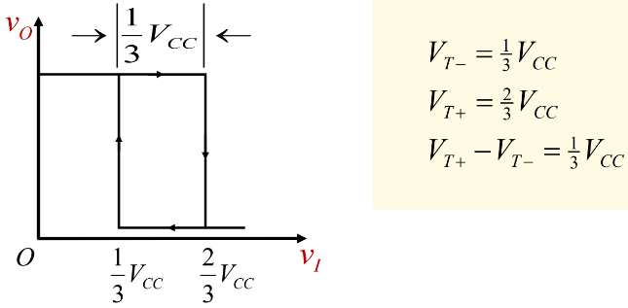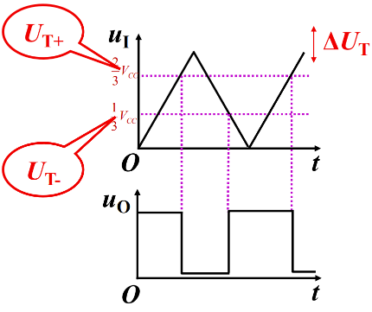

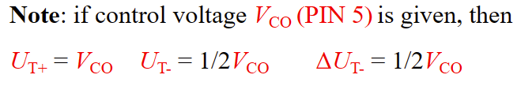

# 9.1 Finite State Machine

Moore Model: Outputs only depend on current state. (仅取决于当前状态)

Mealy Model: Outputs depend on current state and inputs (取决于当前状态和输入)

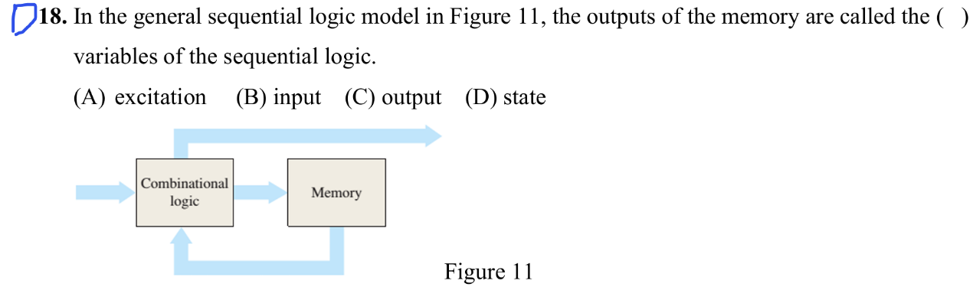例题：2020 A卷

# 9.2 Asynchronous Counters（异步计数器）

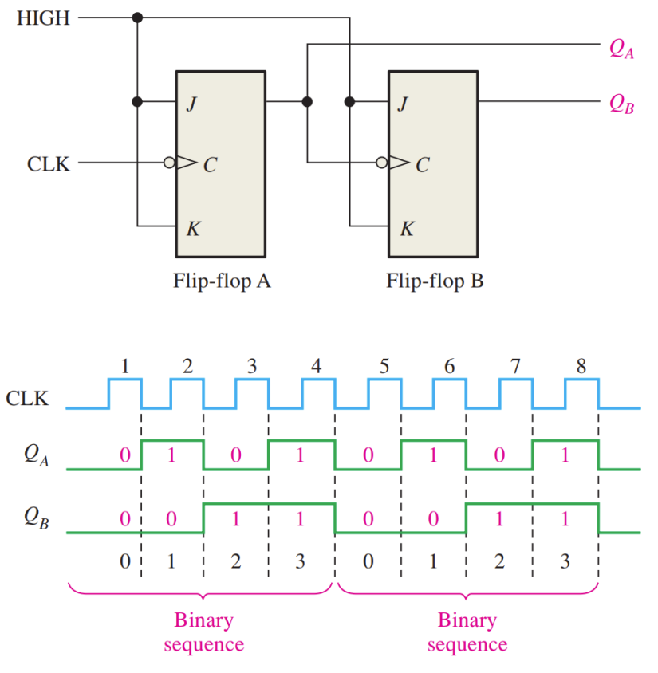

记2的n次方需要n个触发器

考虑传输延迟的影响：Tmin=ntp（其中tp是每个J-K触发器的propagation delay time）

以此可以来计算最大的clock frequency

例：假设从trigger到output需要8ns，则最大周期是24ns

Occur when Q0Q1Q2 from 110 to 001 or from 111 to 000

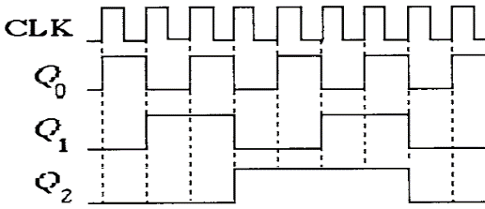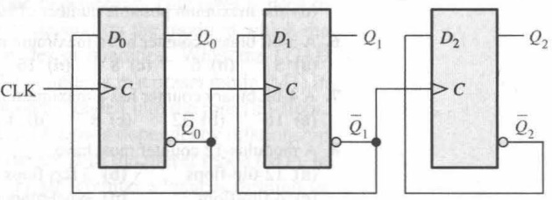

Truncated sequence (截尾序列): the number of states is less than 2n

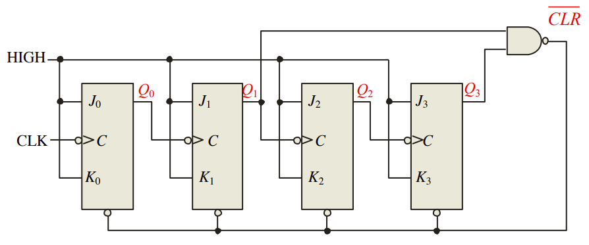Eg:模为10，即译码1010，即Q1Q3第一次同时为1，此时清零

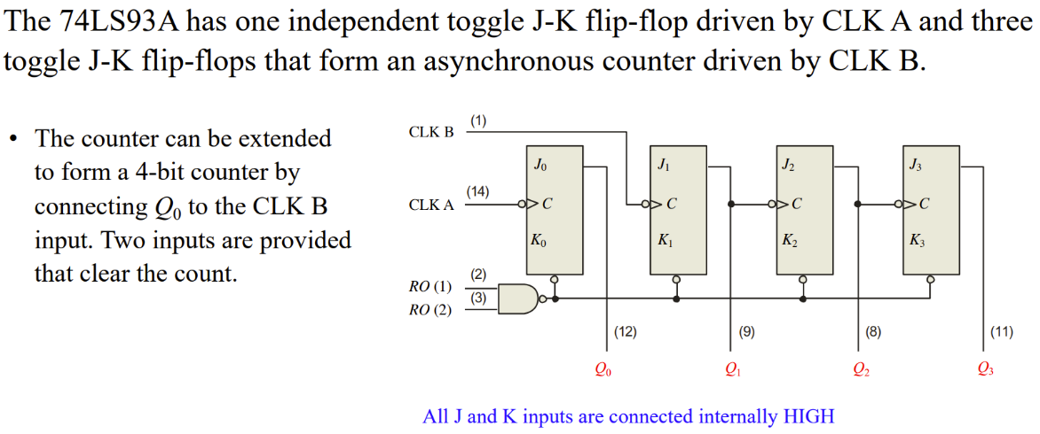

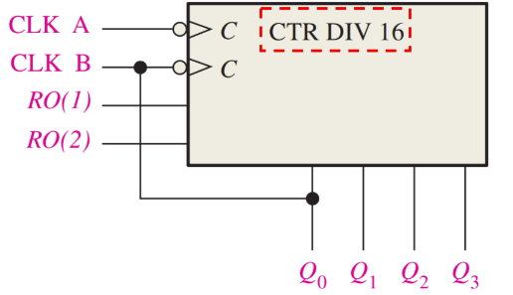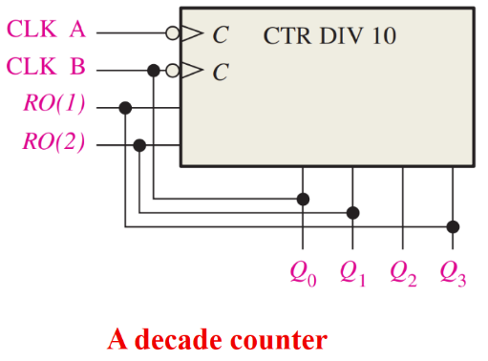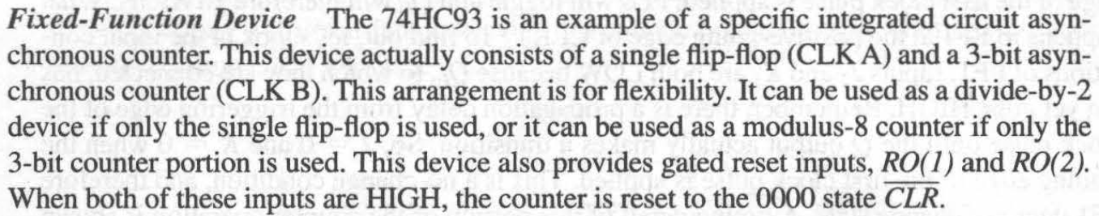

设计模为13的计数器

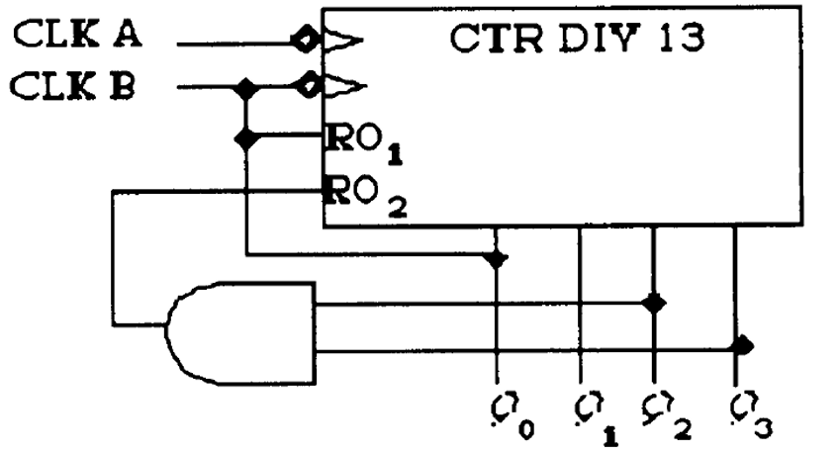

# 9.3 Synchronous Counters (同步计数器)

2-bit Synchronous Binary Counter：

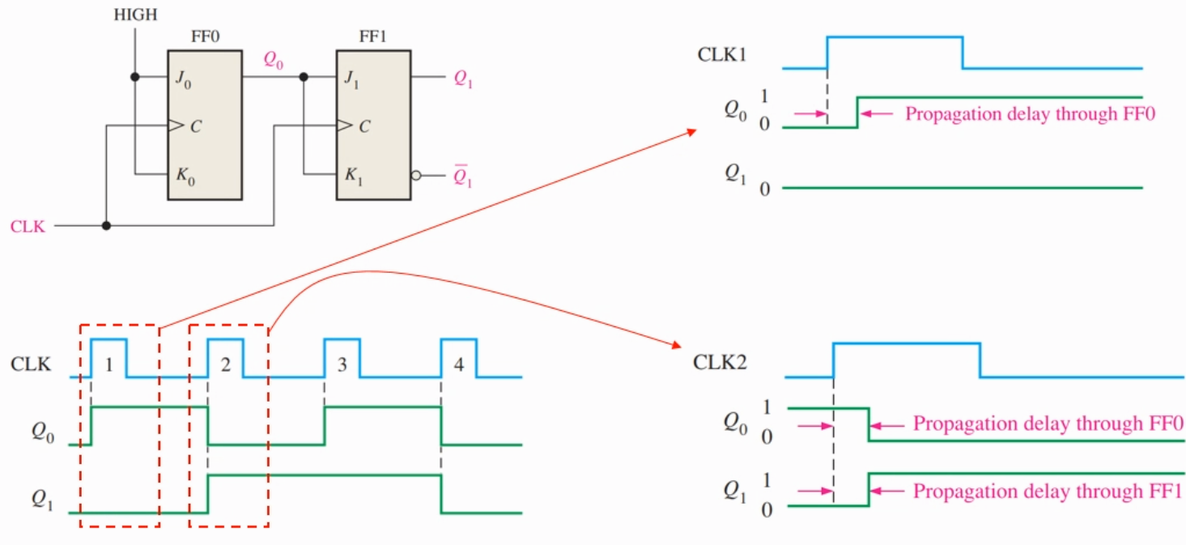

3-bit Synchronous Binary Counter：

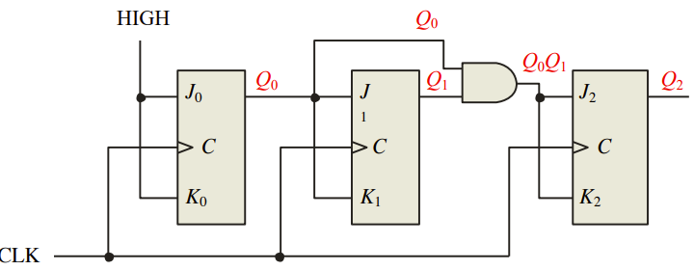

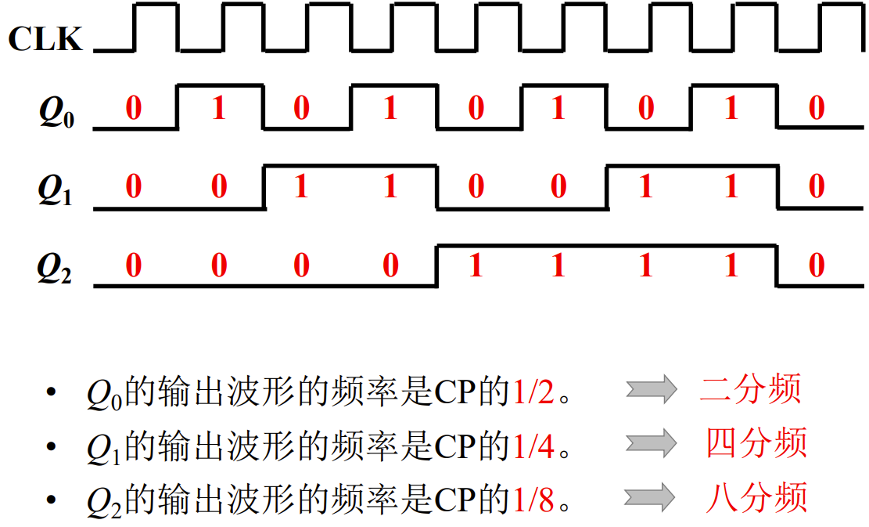

4-bit Synchronous Binary Counter：

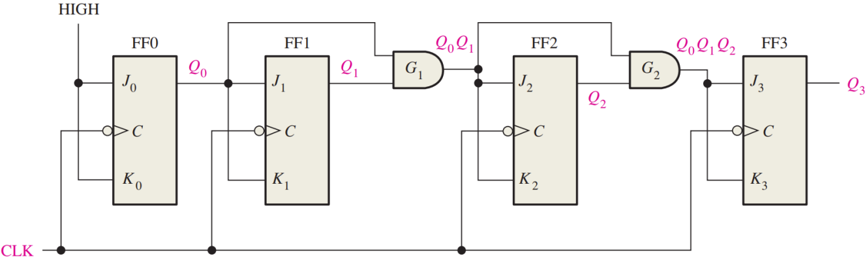

BCD Decade Counter：

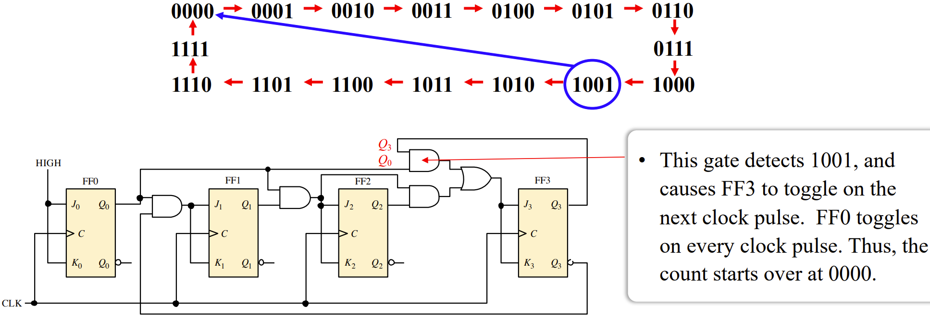

例题：

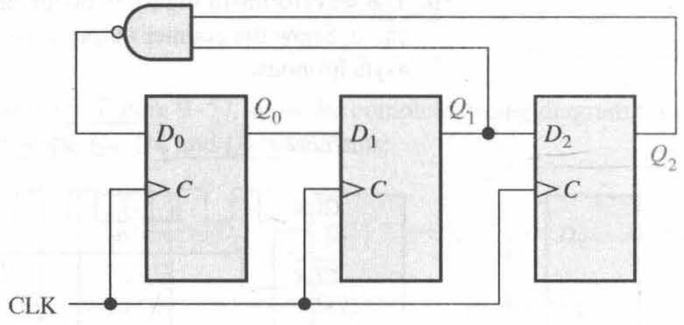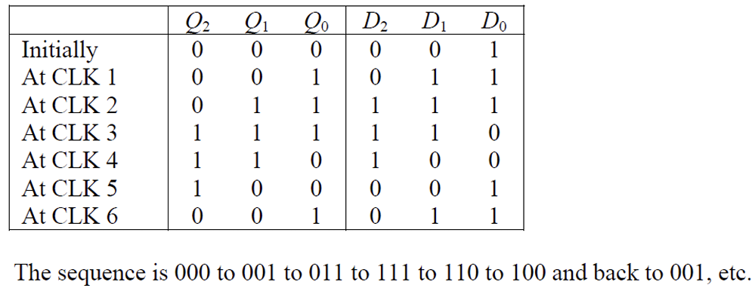

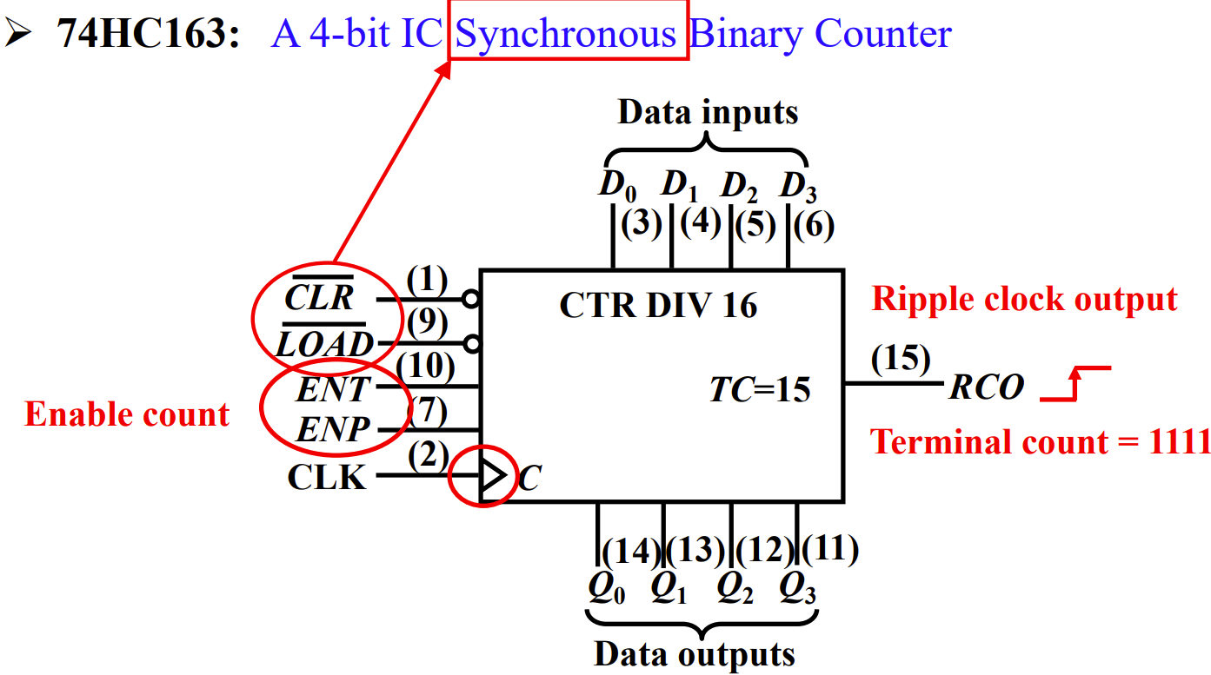

功能表的解读：

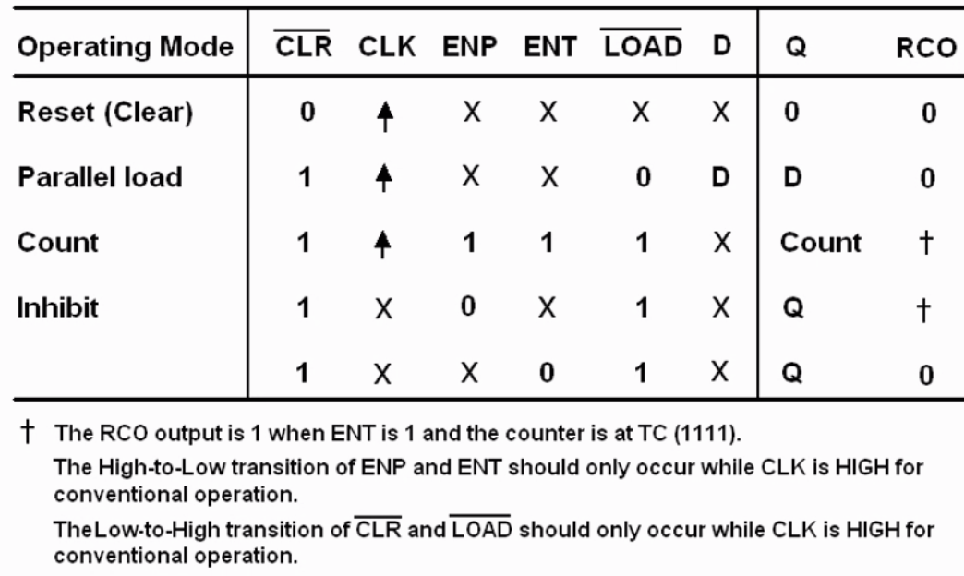

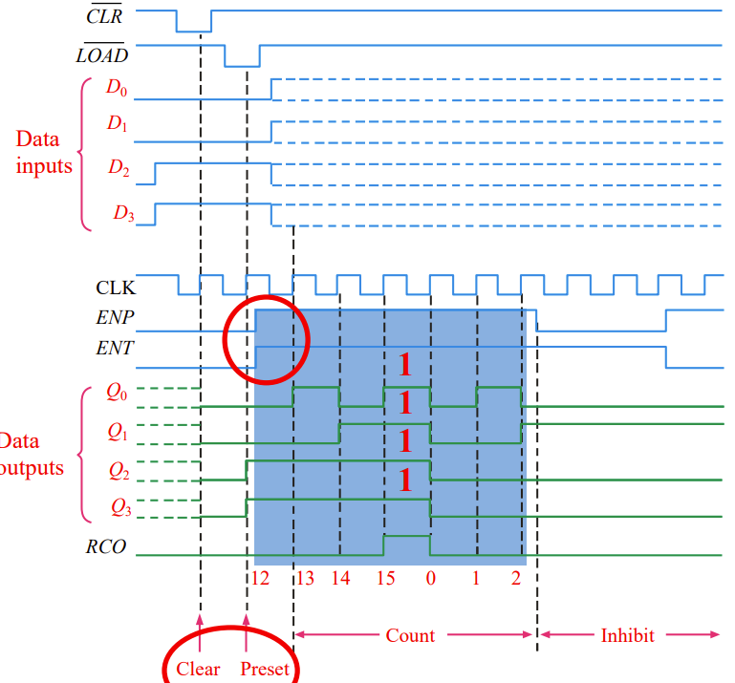

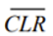为有效电平，要等到时钟上升沿，将Data outputs清零。

可以预置数，当为有效电平，且时钟上升沿，可将预置数输出。

当且仅当ENP ENT均1时，计数

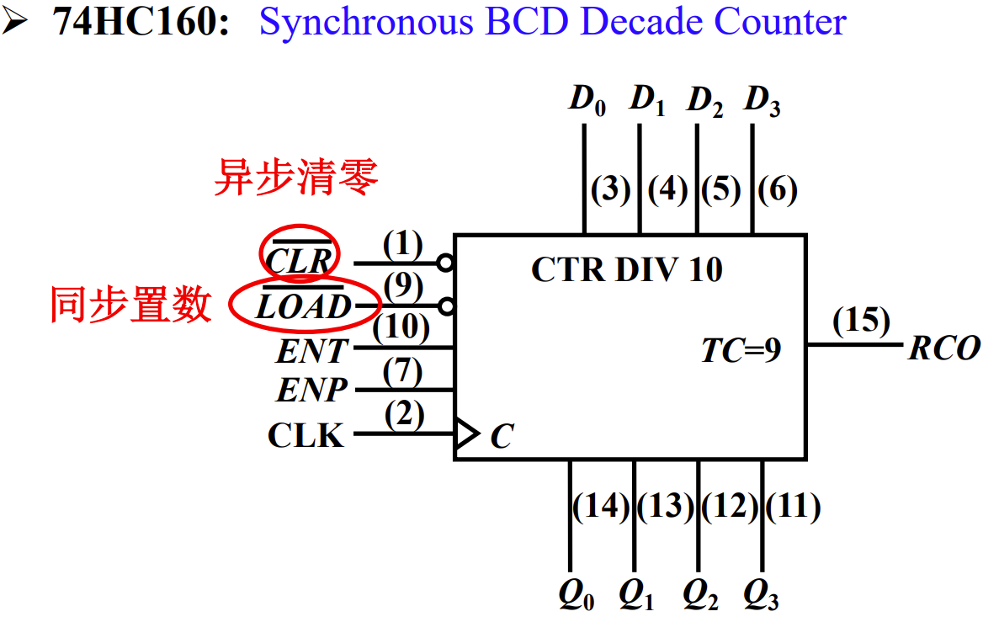

用74HC163实现一个模小于16(如12)的同步计数器：

1. 清零，译码1011
2. 置数（注意高低位）

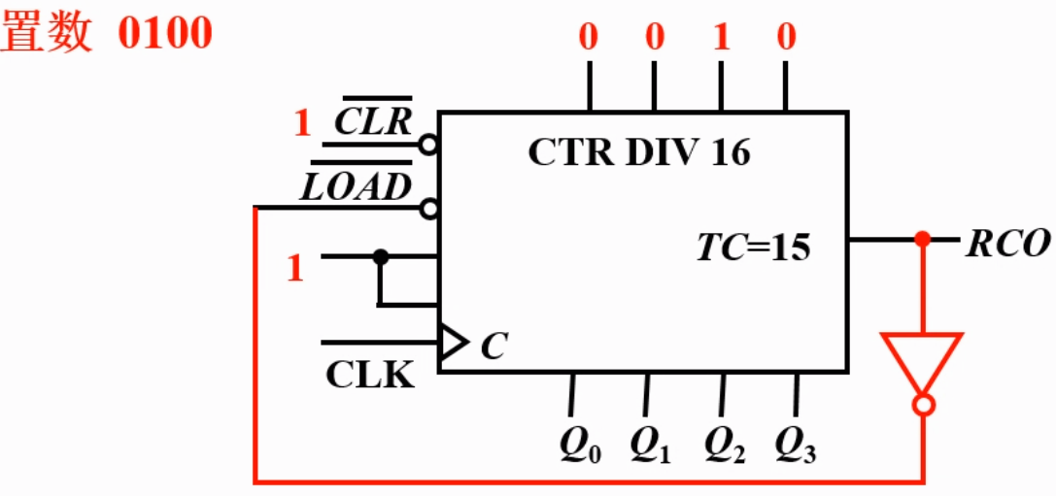

清零的差异：

例如模为12的计数器，若异步清零，则译码12（1100），若同步清零，则译码11（1011）

# 9.4 Up/Down Synchronous Counters (递增/递减同步计数器)

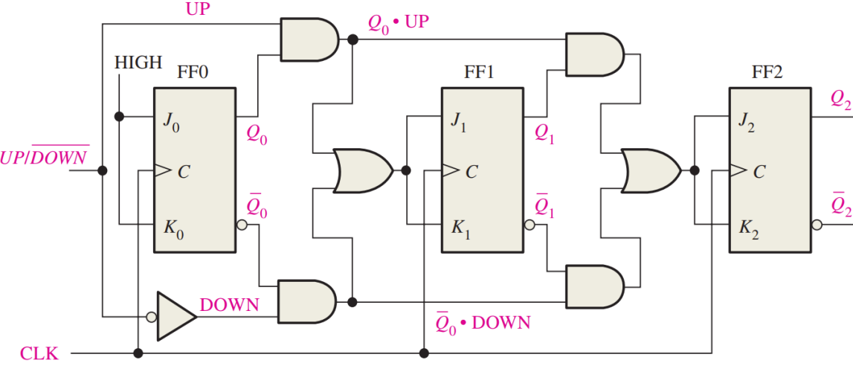

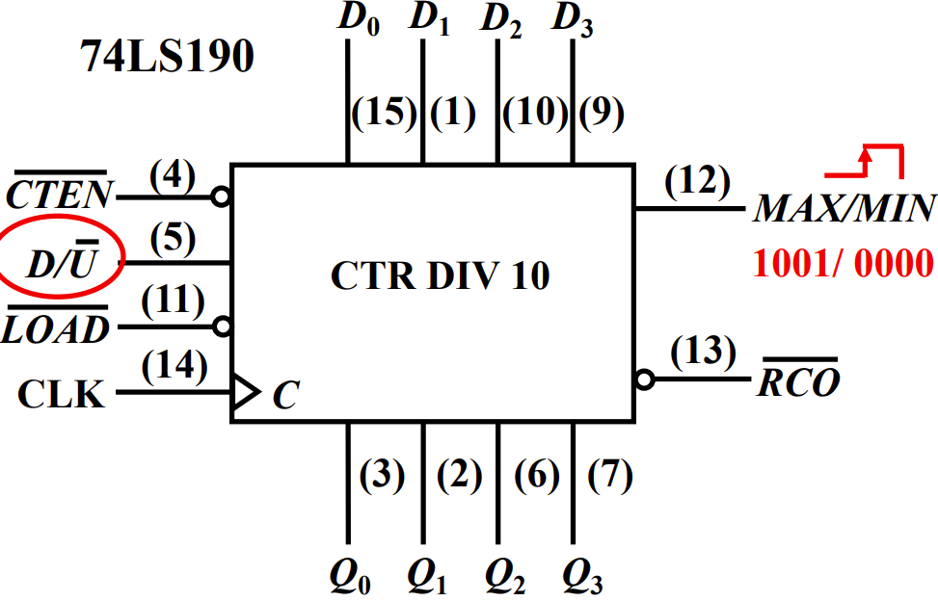load是异步置数

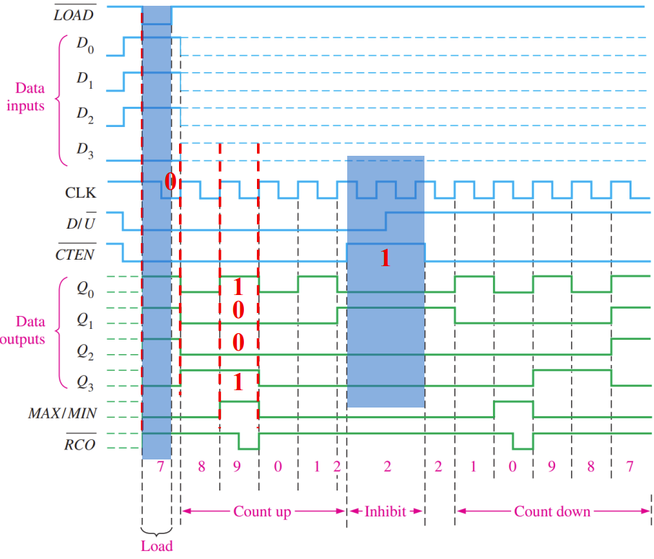

# 9.5 Design of Synchronous Counters (同步计数器设计)

**Analysis of Synchronous Sequential Circuit：**

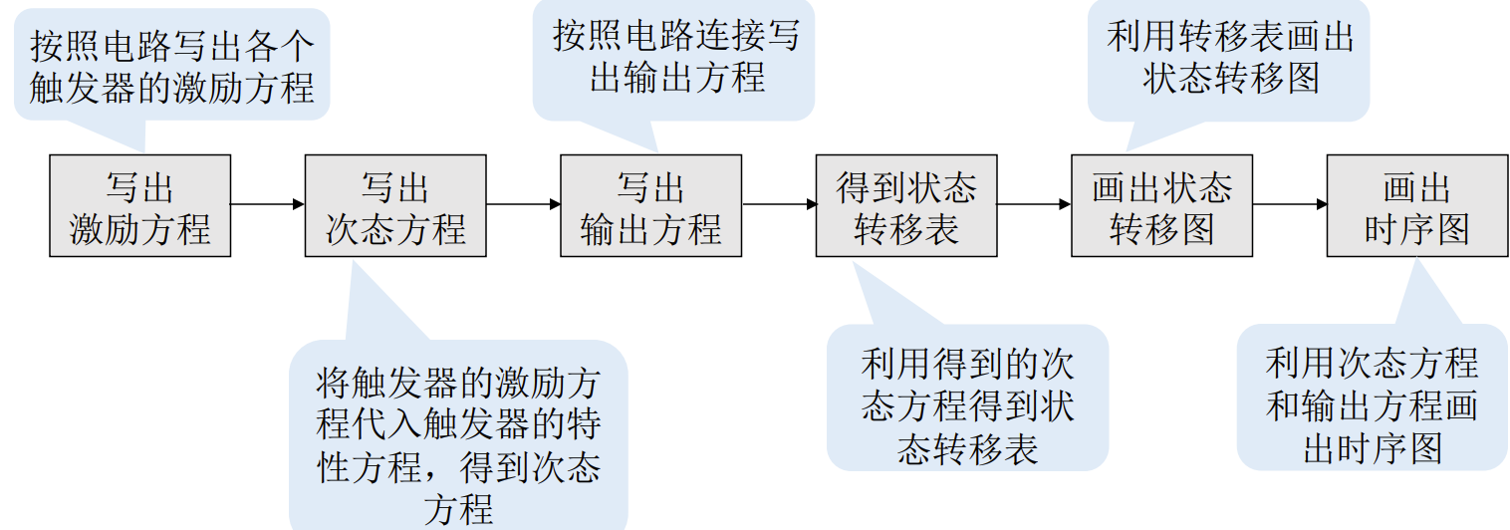

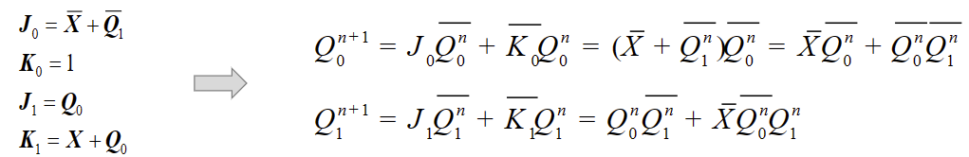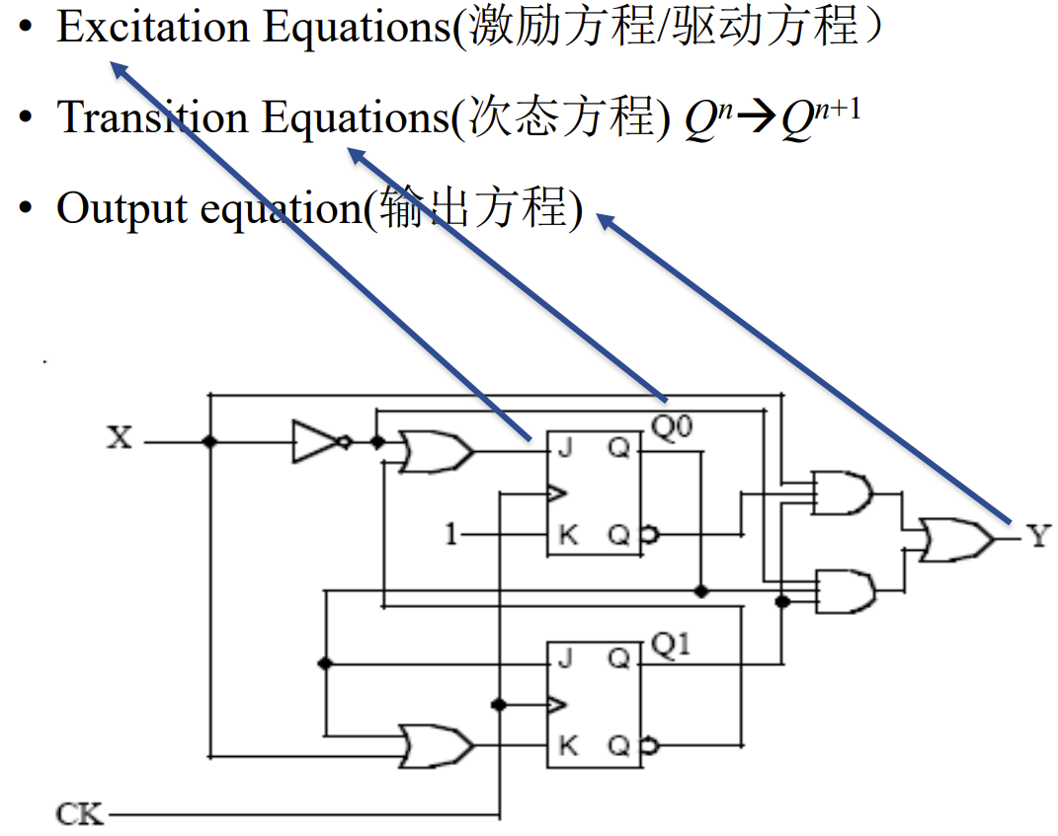

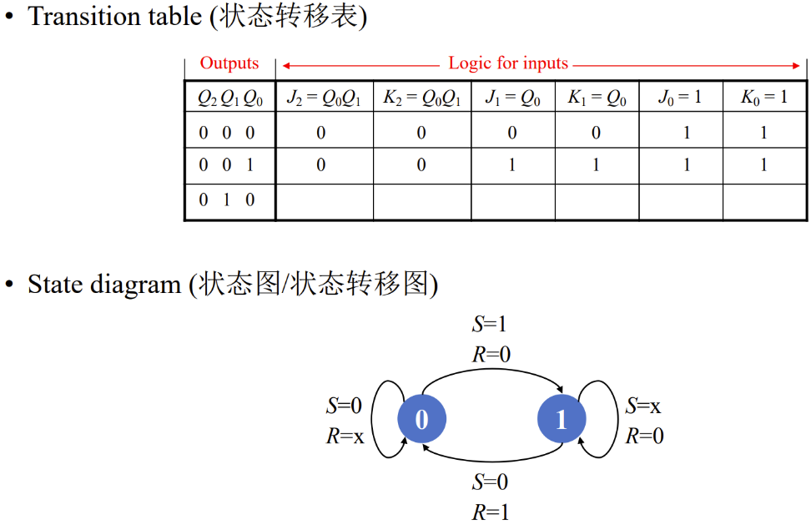

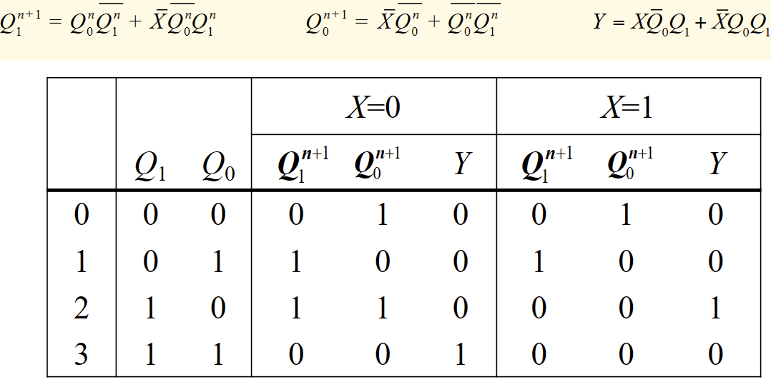

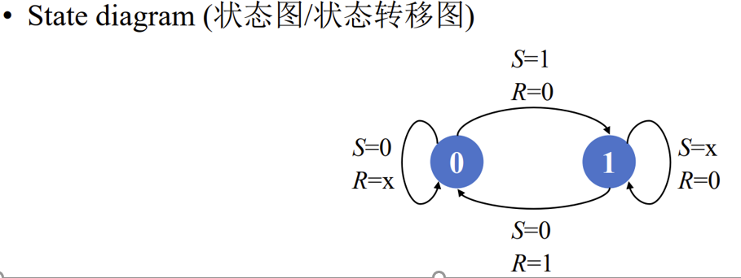 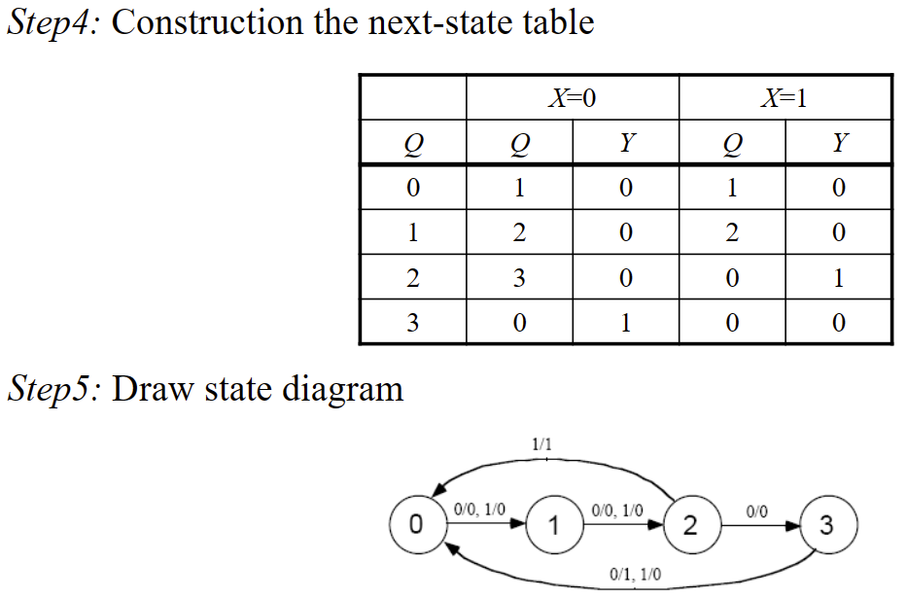

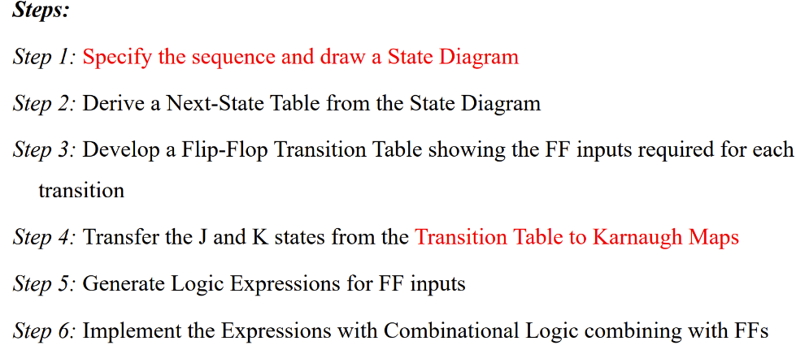**Design:**

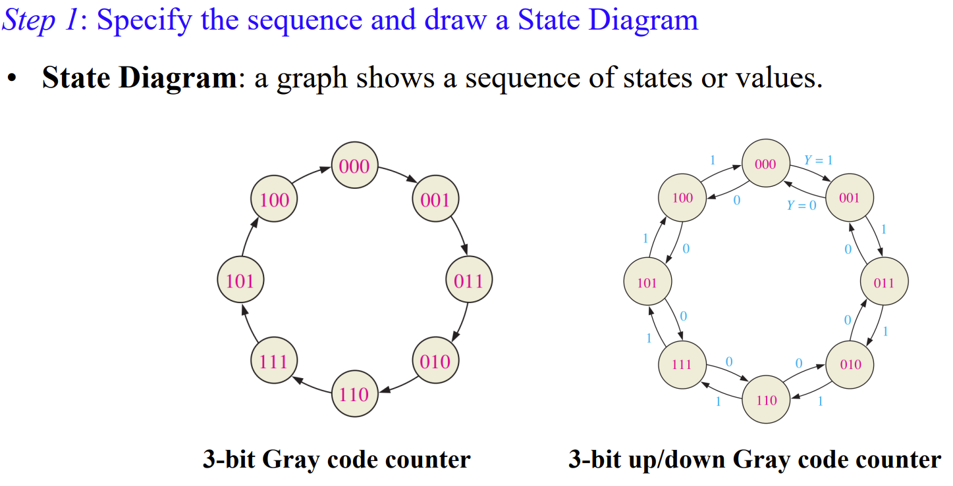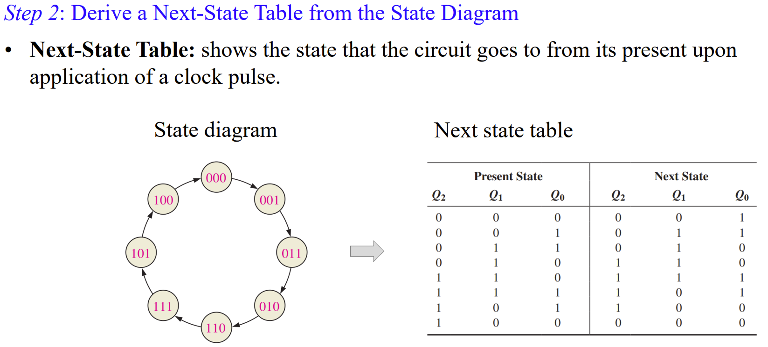

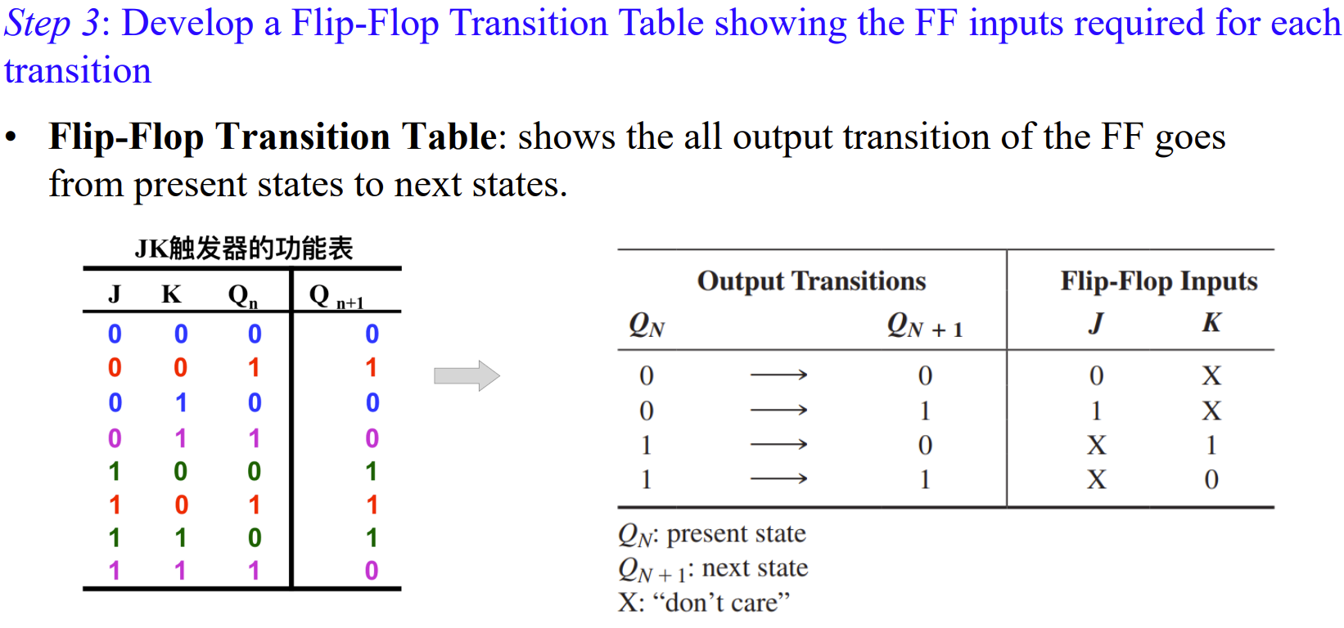

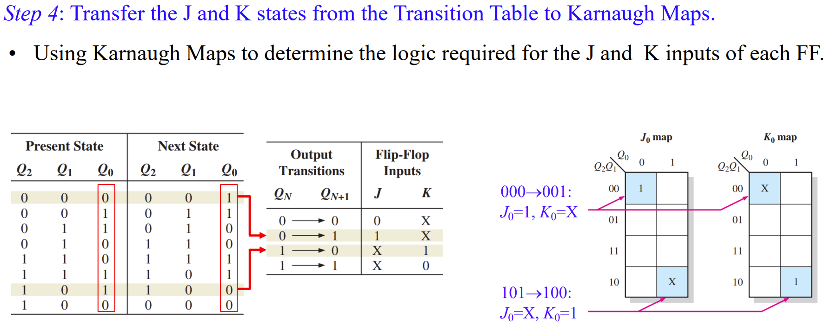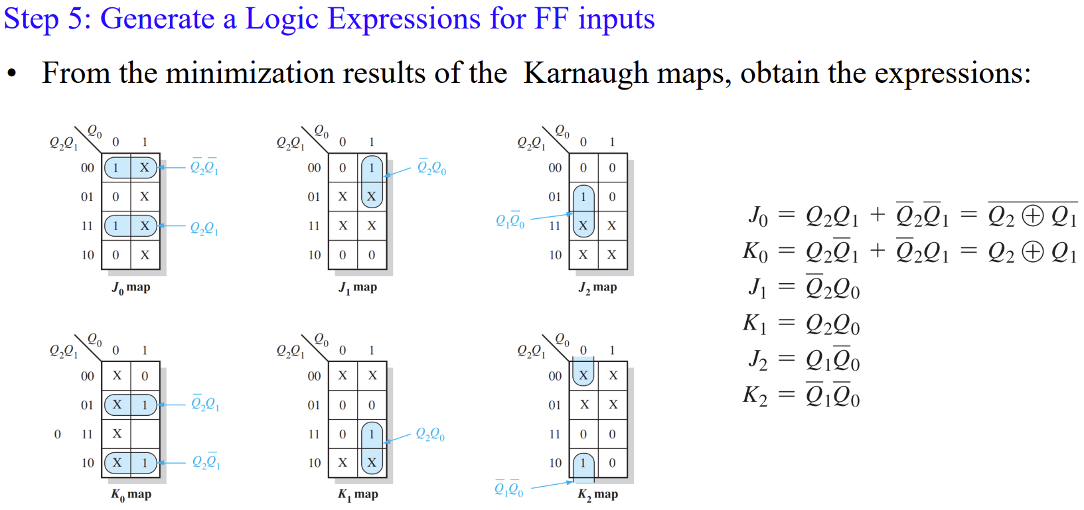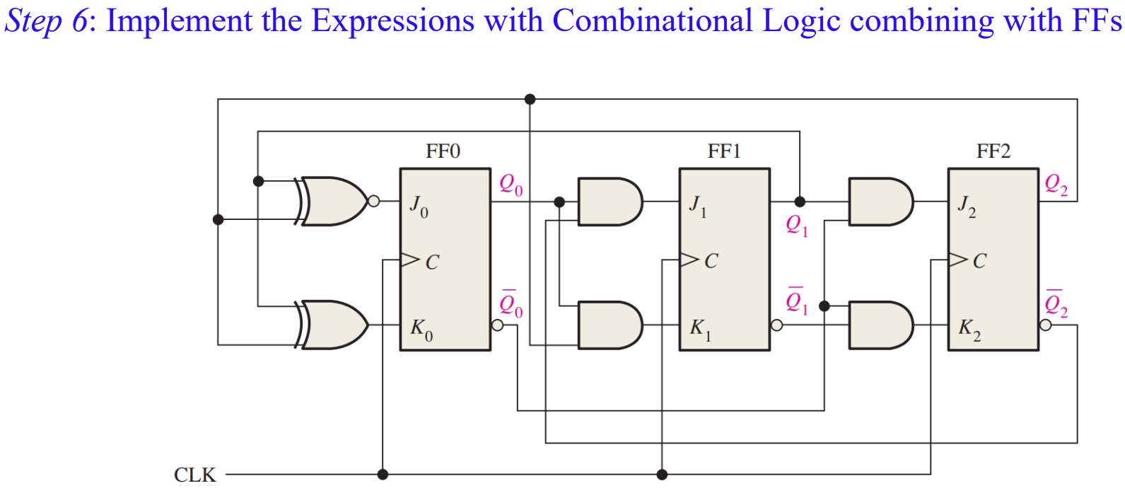

例题：2020 A卷



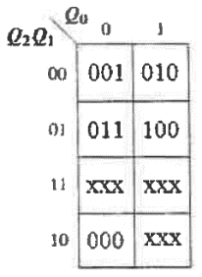

写出左侧next table 图

D触发器Qn+1=D;

根据图上写出Qi为1时的表达式，即为Di

例题：

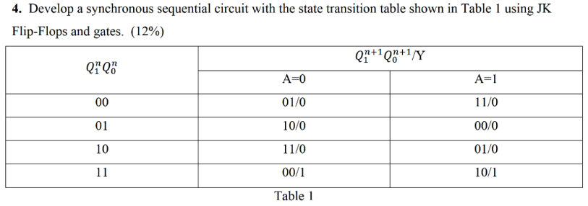

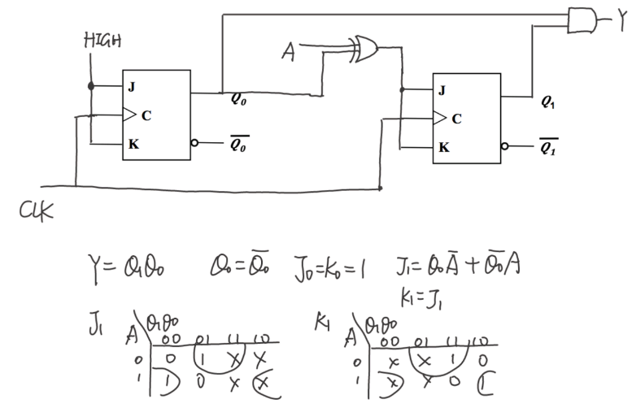

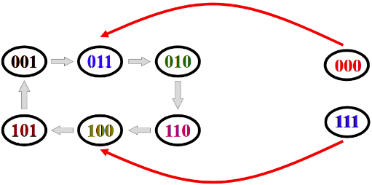Question: the capacity of the counter? 6

# 9.6 Cascaded Counters (级联计数器)

模数计算：多个计数器模数相乘

同步/异步连接方式：

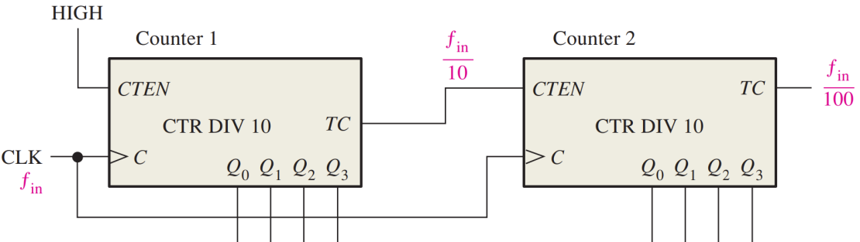同时也是 frequency divider

A divide-by-100 counter using two 74HC160:

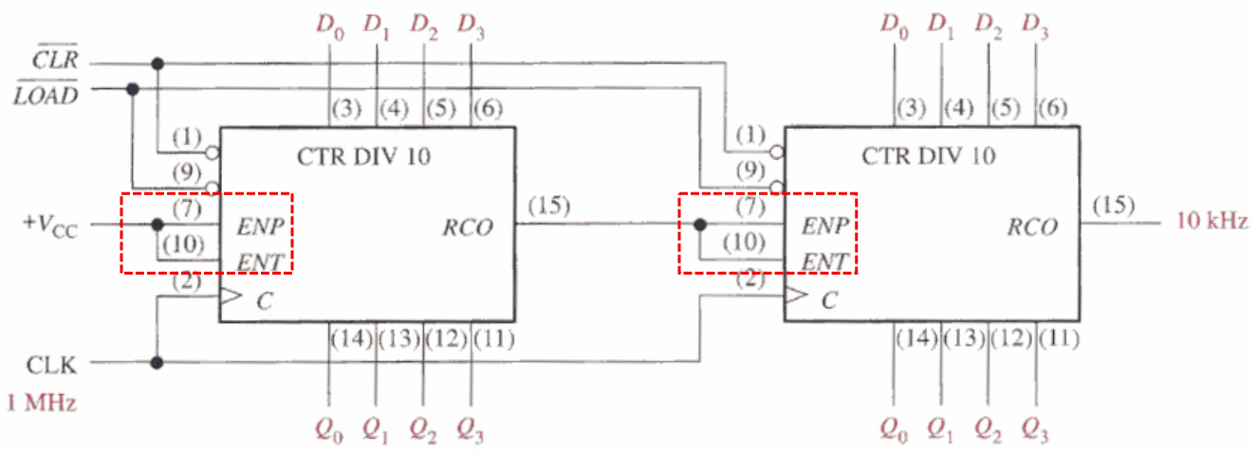

如何实现大模数的计数器：

确定小模数计数器的个数，然后预置数（数值直接相减，记得改变进制）

例题：模数为16*16-2C=212

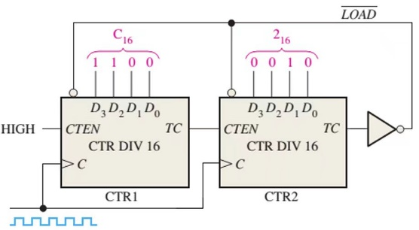

# 9.7 Counter Decoding (计数器译码)

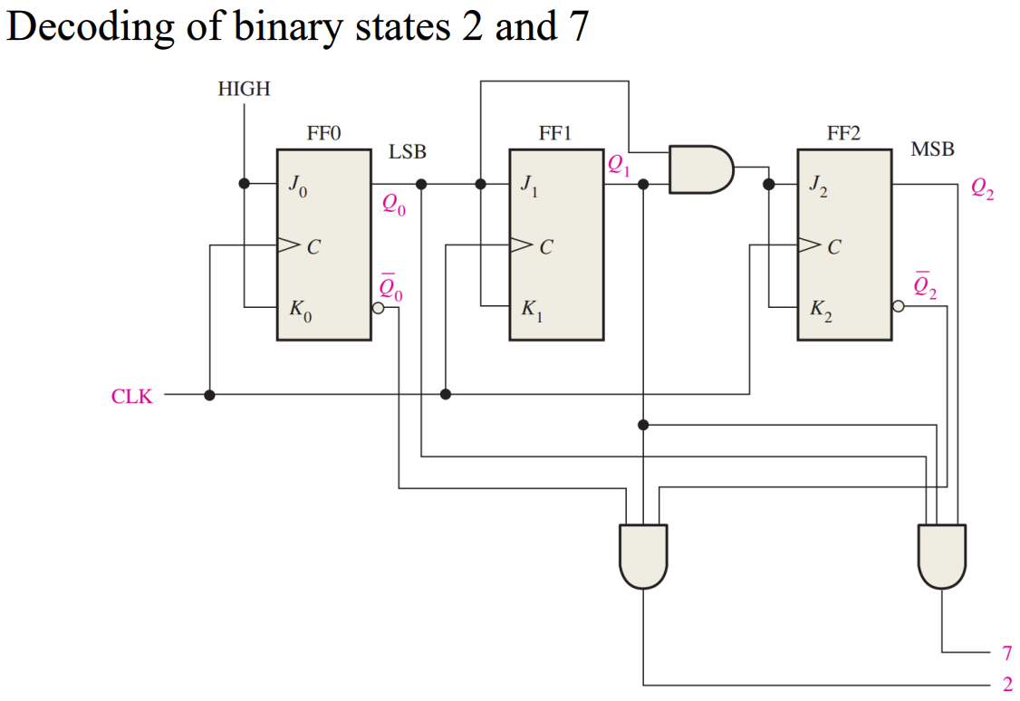

Partial Decoding：the first occurrence of this combination in the sequence

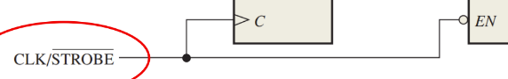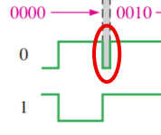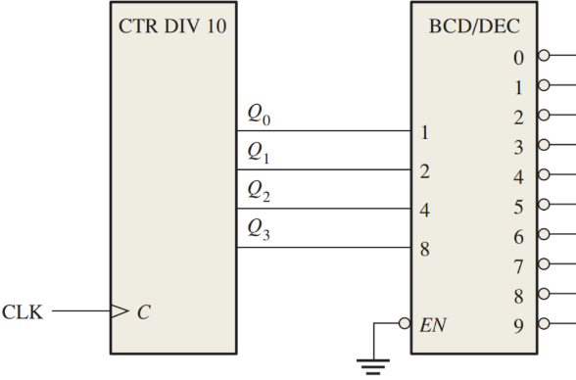Decoding Glitches：

CLK为HIGH期间，EN端不工作，下降沿之后译码器才工作，这样避免了glitch

# 9.8 Counter Applications (计数器应用)

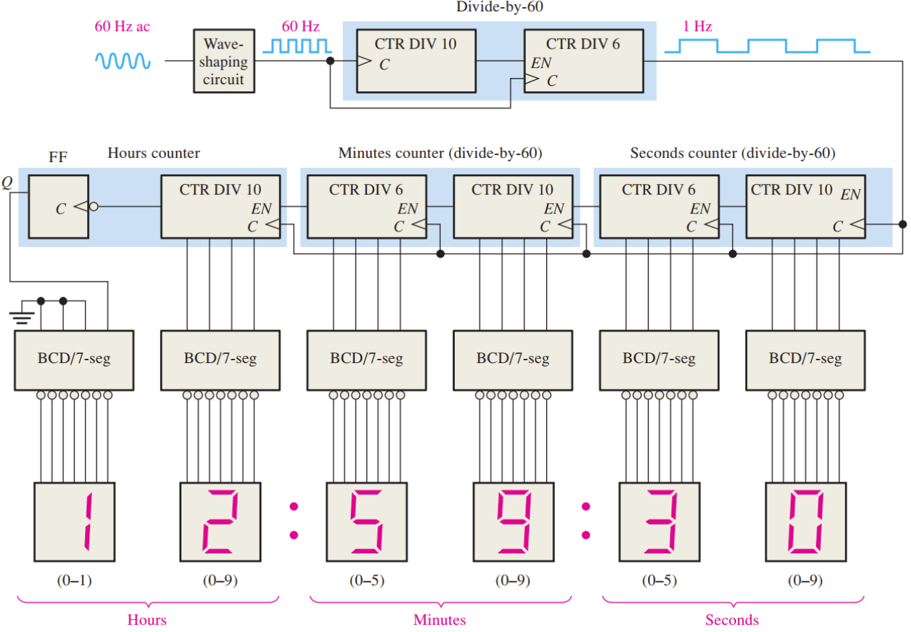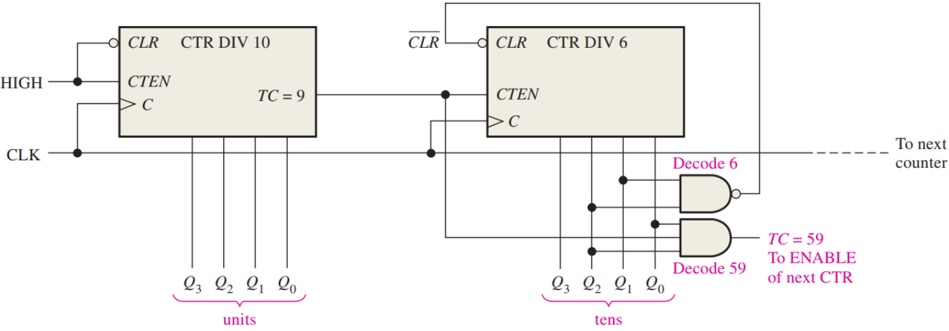

同步清零

